Cancer Care Ontario (CCO) ISAAC Application

Admin User Guide
Version 1.4
Last Updated: April 2016

User Guide Table of Contents
This package is intended to be available to nurses, physicians, managers and IT personnel at facilities that have implemented the ISAAC application in their clinics. This guide provides detailed information on the CCO ISAAC web application’s Admin Portal with respect to the features and functionality offered. Included is an overview of the following:
About This Guide 3
Overview 3
Audience and Purpose 3
Organization 3
Background 4
ISAAC Overview 4
User Roles 5
Overview 5
Patient Registrant 5
Notification User 5
Site Reports Admin 5
Site Admin 5
Accessing the ISAAC Admin Portal 6
Web Link 6
Reset Password 6
Common Tools and Functions 7
Notifications Tab 11
Filtering Notifications 11
Close Notifications 11
View the End of Survey Report 11
Patient Tab 12
Patient Search 12
Enroll Patient 12
Edit Demographics 14
Managing Survey Responses 15
Opening the Surveys Responses Popup 15
Add Survey Responses 16
Edit Survey Responses 16
Delete Survey Responses 17
Resend Survey Responses to Hospital Information System 17
View/Print End of Survey Report 18
Reports Tab 20
Accessing Reports 20
Report Breakdowns 21
Configuration Tab 22
Site Configuration 22
Kiosk Configuration 25
Users Tab 27
Survey Tab 28
Survey Grid 28
Survey Status and Type 28
Survey General Tab 29
Survey Actions Tab 31
Survey Notification Setup Tab 32
Survey Summary Tab 34
File Upload Tab 35
Upload File 35
File Upload Status 35
File Upload Error and Warning Messages List 37
File Upload Template 38
Helpdesk 39
Help Page 39
Feedback Tab 40
Appendix A: Version History 41
Document History 41
Appendix B: List of Figures 42

About This Guide

Overview
This guide outlines the features and functionality of the ISAAC Admin Portal for the use of hospital users. Content is outlined with descriptions, figures and screenshots to facilitate a better understanding of the application. The patient portal and UMA web portal are outlined in other guides.

Audience and Purpose
This user guide is intended to support internal CCO users of the CCO ISAAC application, specifically Patient Registrants, Site Report Admin and Site Admin. The guide aims to provide instruction on how to navigate through the application and complete different functionalities within the application based on your role. Instructions are included to guide users on:
• Closing notifications  • Filtering notifications  • Viewing the End of the Survey Report  • Enrolling patients  • Editing existing patients demographics  • Adding survey responses for internal surveys  • Editing survey responses for internal surveys  • Deleting survey responses  • Viewing reports | • Setting up site configuration  • Setting up kiosk configuration  • Editing survey settings  • Creating notification schedule  • Creating actions  • Granting users permission to close notifications  • Creating notification schedule exceptions  • Downloading file template  • Uploading file template  • Viewing the upload search history

Organization

Table of Contents
Outlines the overall structure and content of this document and is hyperlinked for easy navigation to chapters or sections within the guide.

Chapters
Each chapter groups related information and is likely to have multiple sections and hyperlinks to other sections within the guide, as well as to external reference material in the ISAAC Implementation Toolkit.

Background

ISAAC Overview
An extensive body of literature shows that cancer and its treatment negatively impact the physical, psychosocial and existential-spiritual domains of patients’ health. Patients tend to under-report their symptoms in conversations with clinicians and symptoms are under-recognized and under-treated. Additionally, patients report a low quality of support for activation in self-management of their symptoms. Combined, these issues result in a gap of clinical management which can lead to significant physical and psychological morbidity, negative consequences for quality of life and possibly mortality. Healthcare costs are expected to escalate in coming years, with an increasing incidence of cancer and a burgeoning survivor population living with cancer as a chronic disease.
Globally, the use of patient-reported data is now a health system imperative to ensure early and efficient detection of these problems, to evaluate the effects of interventions on health outcomes and to monitor the quality of care from the patients’ perspective. The main tools advocated for capturing the patients’ perspectives about the effects of cancer and its treatment are: (1) patient-reported outcome measures (PROMs), which measure the impact of an illness and effects of interventions (e.g. quality of life, symptom severity, functional status, health status); and (2) patient-reported experience measures (PREMs) that capture patients’ views of what happened during the health encounter (i.e. processes of care), as a metric for quality of care or service performance.
Cancer Care Ontario’s (CCO) Interactive Symptom Assessment and Collection (ISAAC) tool allows patients to assess and monitor their symptoms through an easy to use, standardized, secure, web-based application. ISAAC allows patients to complete survey assessments electronically on a touch-screen kiosk at their local cancer centre, or from the convenience of their Internet-linked home computer or mobile device. The assessments are then reviewed by the patients’ care team which allows symptoms to be managed more effectively and facilitates appropriate care planning. Clinicians can access their patients’ symptom information, regardless of where the patient has entered their scores and can track this information over time.

User Roles

Overview
ISAAC users can be granted one or more roles which can be updated by a Site User Admin or by the ISAAC helpdesk at any time. Each user role has access to specific “tabs” within the ISAAC Admin Portal and their contained functionality.

Patient Registrant
This user only has access to the Patient and File Upload tabs. Enrolls patients, searches for existing patients, and edits patient demographics. Uploads bulk survey responses, downloads file templates (Patient enrollment, survey submissions), view file upload status. Views/prints existing survey responses, and edits existing survey responses.

Notification User
This user only has access to the Notification and Users tabs. Views and closes notifications. Creates and views notification exceptions

Site Reports Admin
This user only has access to the Reports tab. Views the reports generated within ISAAC displaying collected data for: Kiosk Use, Notifications, Patient Registration Reports and Integration reports.

Site Admin
This user has access to All ISAAC tabs. This roles has the permission to use the features and tabs or all previously outlined users as well as the following functionality:
- Setting up site configurations (messaging, notifications, reports, etc.)
- Setting up kiosk configurations (surveys, printouts, language, etc.)
- Creating actions and supplementary Information printouts
- Creating notification schedules
- Granting permissions for user to close notifications

Accessing the ISAAC Admin Portal

Web Link
The ISAAC Admin Application can be accessed via your internet browser at the following link:
https://isaacadmin.cancercare.on.ca
Your username and temporary password will be given to you by your ISAAC Local Registration Authority (LRA) or UMA (User Management Application) Administrator.

Reset Password
After logging in to the ISAAC Admin Application for the first time, your password should be reset by selecting the Change Password link.
Figure 1: The Password Change Link
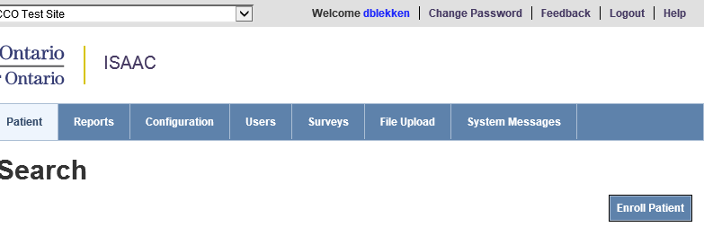
Your user name will default. Please enter your old password, followed by your new password, and new password confirmation. If successful, you will receive a message that the password change was successful. Passwords must follow the password security policy below.
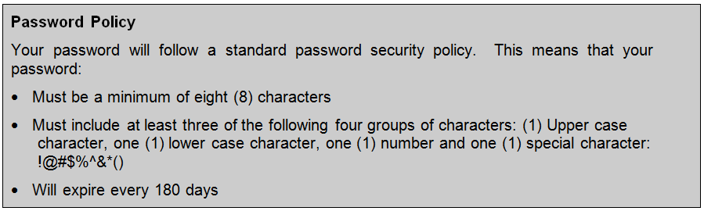
Please note: you cannot change your password more than once in a 24-hour period.

Common Tools and Functions
This section identifies the tools and functions that are common across the CCO ISAAC Admin application and provides guidance on how to use these features.

Grid Controls
Throughout the application there are tables of information displayed in a grid layout. These grids function in a constant manner across the application making for a consistent user experience, look and feel.

Paging
Where appropriate, the management grids display data in a fixed number of rows and feature paging to allow the user to jump to view the next set of data. Users may click directly on a page number to go to that page or they may click the arrow directly to the right or left of the page numbers to move just one page ahead or back. They may click the icon to go to the last page in the list or click the icon to move to the first page in the list. In the bottom right corner of each grid, an indication of the number of rows displayed as well as the number of rows available to be displayed is indicated.
Figure 2: Paging Through Grids
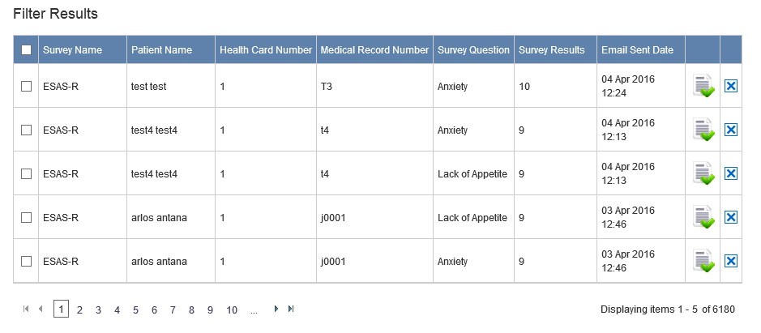

Sorting
The columns of the grid may be sorted where appropriate in either ascending or descending order by clicking on the column heading. The small white arrow next to the column heading indicates which column the grid is sorting and the direction of the white arrow indicates whether the column is sorted in ascending or descending order. The grid may only be sorted by one column at a time.
Figure 3: Sorting Through Grids
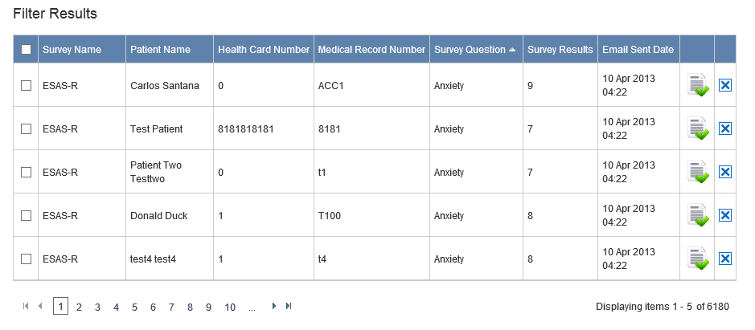

Inline Editing
Some grids contain an inline edit feature which allows users to edit values directly within the grid without leaving the page. The right column of these grids contain:
- Pencil icons depicting the Edit function
- Red X icons depicting the Delete function
- Floppy disc icons depicting the Save function
- Green X icons depicting the Cancel function
Users can click the pencil () icon, perform the edits in place and then click the floppy disc () icon to save their changes or they can click the green X () icon to cancel the edit. The Red X () will delete the entry.
Figure 4: Inline Editing
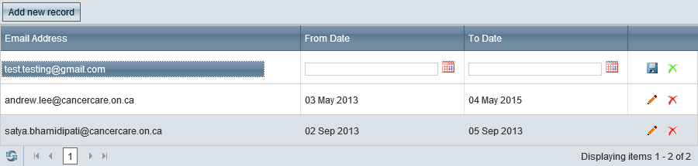

Mandatory Fields
Throughout the application, those fields that are mandatory for a save or update to be completed are identified by the red asterisk symbol (*) to the left of the field label. Data must be entered in these fields for a save or update to be successful. In the event that a user does not enter data for all mandatory fields, the user will be prompted with an on-page message indicating that the attempted update failed and to complete the data input of the listed mandatory fields (highlighted in red).
Figure 5: Mandatory Field Indicators
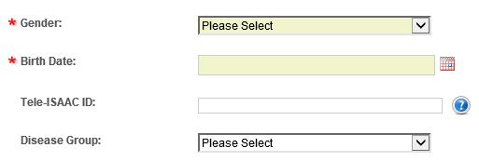

Left Navigation Tool
Throughout the application, there is a left navigation tool from which you can be directed to different pages and functions. It is used to access grouped functionalities such as the Surveys and Configuration tabs.
Figure 6: Left Navigation Tool
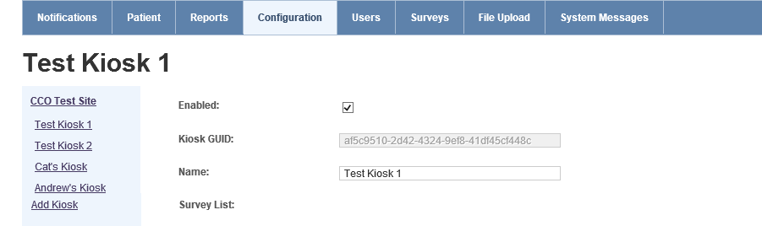

Expand and Collapse Functions
Across the application there are subsections of pages that may be expanded or collapsed at the discretion of the user. These sections are identified by a plus or minus icon to the left of a section subheading. Users may click the icon to expand or icon to collapse subsections. The purpose of this feature is to allow users to hide information that they do not need to view immediately, so the sections that are important to them may remain easily in view on the page without the need for excessive vertical scrolling.
Figure 7: Expand and Collapse Functions
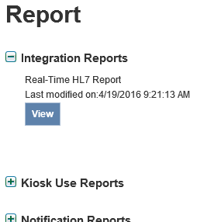

Multi-Site Selection
If you are a user with access to multiple sites such as a region cancer centre and a number of satellite hospitals you can switch between sites with your single ISAAC user account. At the top of each page, there is a “Site Selection” dropdown where you can pick the site you would like to access from the dropdown.
Figure 8: Multi-Site Selection Dropdown
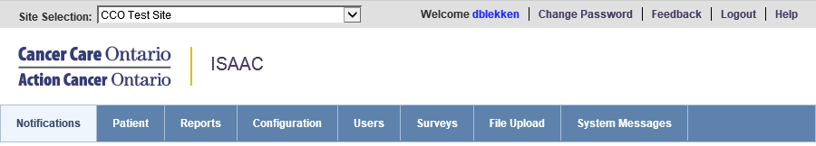

Notifications Tab
This chapter instructs the Site Admin on how to filter through notifications, close a notification and view the End of Survey Report of a patient. The Notification tab is the homepage of the ISAAC application for users who have access to it. When notifications are triggered by patients they are logged and displayed in the Notification homepage.

Filtering Notifications
To filter the notifications for a specific survey and survey question:
- Select a survey from the Survey Name drop down.
- Select a question from the Survey Question drop down.
- Select a user from the User drop down. (Note: The username of the user currently logged in will be the default value. You can clear the filter by selecting the blank value at the top of the drop down menu).
- Click on the Filter button.

Close Notifications
Closing a notification is an acknowledgement that you have read the notification and would like to remove it from the grid. To close a notification, click on the icon in the grid to acknowledge that you have read the notification.

View the End of Survey Report
You can view the End of Survey Report for the notification by clicking on the icon in the grid.
Figure 9: The Notification Tab Home Page
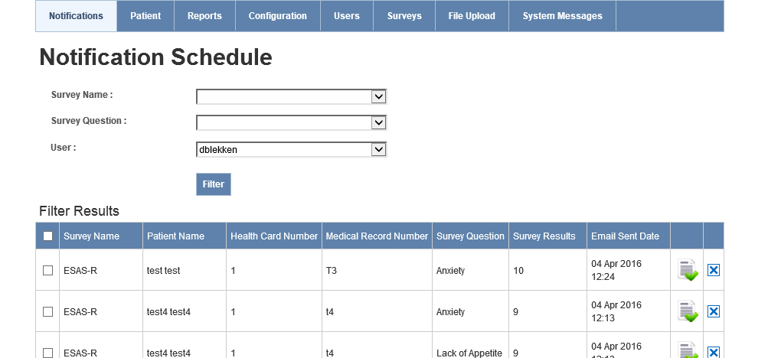

Patient Tab
This chapter instructs the Patient Registrant and Site Admin on how to search patients, enroll patients, edit existing patients demographic, discharge existing patients, and view, edit and add new survey responses.

Patient Search
You can search for patients from the initial screen displayed after clicking on the Patient tab. Search supports 2 options:
- Search by Ontario Health Card Number (HCN) or Hospital Medical Record Number (MRN)
- Search by patient name (full first and last name required)
Select the subtab for the search you wish to use and enter the patient information. Type Enter or click Search to have ISAAC display the results in a table.
Figure 10: Patient Search Feature
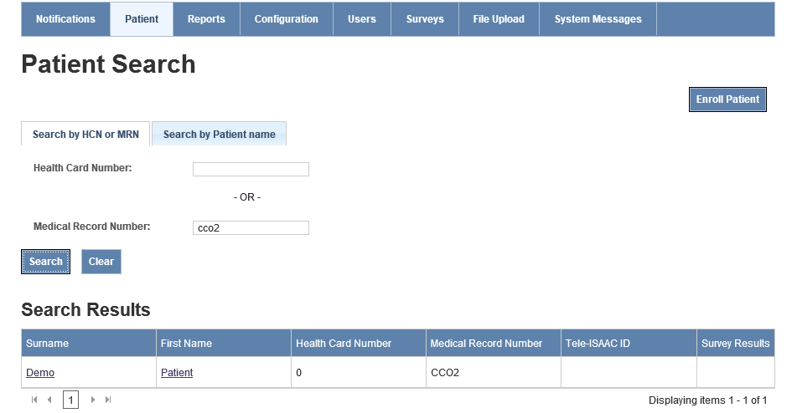
2. Choose your search method
4. Click Search
3. Enter patient info
1. Select Patient tab

Enroll Patient
To enroll a new patient:
- Click on Patient tab.
- You must first complete a patient search to make sure the patient does not already exist in the ISAAC application.
- To search for existing patient, you can search by the patient’s Ontario Health Card Number or Medical Record Number.
- If no search results are found, then click on the Enroll Patient button. Search for the patient again by their Health Card Number or Medical Record Number. If this patient is not enrolled at any other sites, click New Enrollment. If you have searched by Health Card Number and the patient is already enrolled at another site, the form will populate with the patients information from the other site.
Figure 11: Patient Enrollment Form
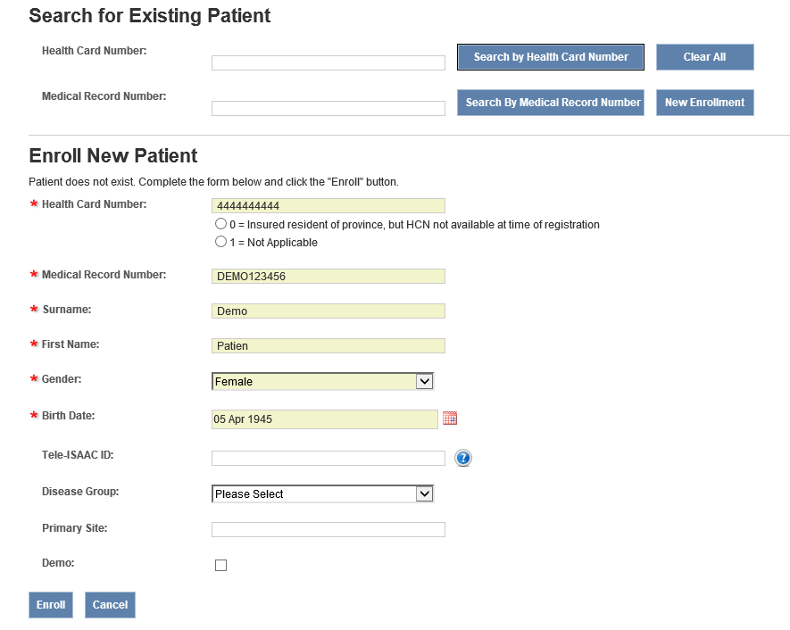
- Fill in the demographics.
Please Note: If the patient was enrolled at another site, updates to the patient will apply to all sites for which the patient is enrolled. The Health Card Number will not be editable. If there appears to be a data quality error or multiple patients exist for a single person, contact the ISAAC helpdesk.
- Make sure the Demo button is not enabled. If enabled, the patient’s data is not saved in the database. This flag is for the purpose of Kiosk Configuration set up.
- Click on Enroll.
  - To abandon enrolling patient, click the Cancel button and any pending changes will not be saved.

Edit Demographics
This section instructs the Patient Registrant and Site Admin on how to edit existing patients’ demographics and patient discharge.
To edit existing patient’s demographics:
- Click on Patient menu.
- From the Patient Search, you can search by the following: Ontario Health Card Number, Medical Record Number, and Patient Name.
- Search results are displayed in a grid with the following columns:
- First Name
- Surname
- Health Card Number
- Medical Record Number
- Tele-ISAAC ID
- Survey Results
- Click on either the patient’s First Name or Surname.
Figure 12: Edit Patient Demographics
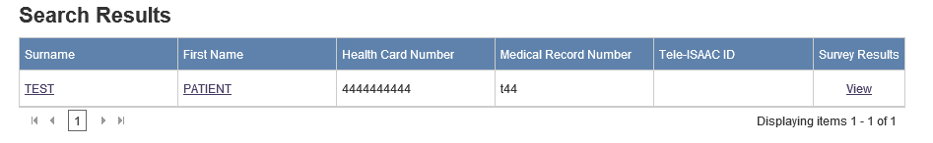
- Edit the demographics you would like to change.
- Click on Save.
  - To abandon editing patient demographics, click the Cancel button and any pending changes will not be saved.

Managing Survey Responses
This section instructs the Site Admin on how to add, edit and delete survey responses and view the End of Survey Report. You can add, edit, and delete survey responses for both internal and external surveys using the Manage Surveys popup from the Patient tab. You can also resend the HL7 message for the response to your Hospital Information System if you have implemented the ISAAC integration features.

Opening the Surveys Responses Popup
To open the survey responses popup:
- Click on Patient tab.
- Search results are displayed in a grid with the following columns:
- Surname, First Name, Health Card Number, Medical Record Number, Tele-ISAAC ID, Survey Results
- Under Survey Results, click on the View button from the grid.
Figure 12: View Survey Responses
- Select a survey from the Survey Name dropdown. The patient’s most recent survey responses are displayed. Use pagination to go to previous survey responses.
Figure 14: Survey Responses Popup
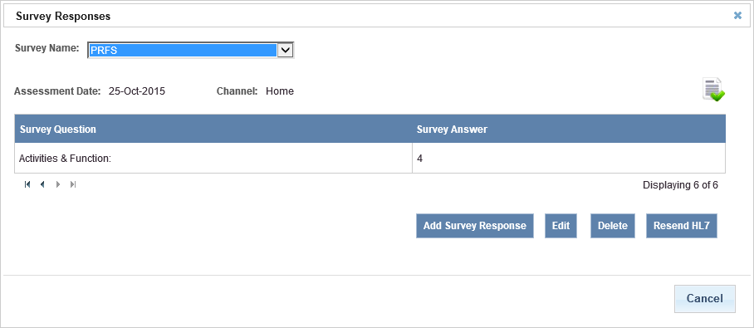
From this page you have access to a number of features to manage the patient’s survey responses. You can add new survey responses, edit existing survey responses, delete survey responses, view end of survey reports, print end of survey reports, resend HL7 message for survey responses back to the Hospital Information System (Only for sites utilizing the integration features of ISAAC).

Add Survey Responses
To add survey responses:
- Open the Survey Response popup as explained in the above section.
- Select a survey from the Survey Name dropdown
- Click on the Add Survey Responses button to create a new survey response. If will be marked with the “Paper” channel.
- Enter an Assessment Date, using the date picker or manually enter YYYYMMDD.
- Complete the survey and then click on Submit.
  - To abandon adding survey responses, click the Cancel button and any pending changes will not be saved.
- The survey response is saved and displayed on the Survey Responses page.
- To close the Survey Responses popup, click on the icon at the top or the Cancel button at the bottom of the pop up page.
Figure 15: Add or Edit Survey Responses

Edit Survey Responses
To edit survey responses:
- Open the Survey Response popup as explained in the above section.
- Select a survey from the Survey Name dropdown
- Click on the Edit button
- You can change the Assessment Date by clicking on the calendar widget.
- Edit the survey responses and then click on Submit.
  - To abandon editing survey responses, click the Cancel button and any pending changes will not be saved.
- The survey responses are saved and displayed on the Survey Responses page.
- To close the Survey Responses popup, click on the icon at the top or the Cancel button at the bottom of the pop up page.

Delete Survey Responses
To delete survey responses:
- Open the Survey Response popup as explained in the above section.
- Select a survey from the Survey Name dropdown
- Click on the Delete button
  - To abandon deleting survey responses, click the Cancel button and any pending changes will not be saved.
  - The user is prompted to confirm the cancellation.
    - Click the OK button to confirm the cancellation.
    - To abandon the deletion, click the Cancel button.
- To close the Survey Responses popup, click on the icon at the top or the Cancel button at the bottom of the pop up page.
Figure 16: Delete or Resend Survey Responses

Resend Survey Responses to Hospital Information System
To resend HL7 message for survey responses you must have HL7 integration with ISAAC or the button will not appear. The button will also be hidden immediately after resending while the message is in progress of sending to the hospital system:
- Open the Survey Response popup as explained in the above section.
- Select a survey from the Survey Name dropdown
- Click on the Delete button
  - To abandon deleting survey responses, click the Cancel button and any pending changes will not be saved.
  - The user is prompted to confirm the cancellation.
    - Click the Submit button to confirm the cancellation.
    - To abandon the resending of an HL7 message, click the Cancel button.
- To close the Survey Responses popup, click on the icon at the top or the Cancel button at the bottom of the pop up page.

View/Print End of Survey Report
To view trended survey responses or reprint the end of survey report for a patient:
- Open the Survey Response popup as explained in the above section.
- Select a survey from the Survey Name dropdown
- Click on the icon
- The End of Survey Histogram report will display in PDF format in a new tab of your internet browser.
  - To print, click on the printer icon or select Print… from the File dropdown
  - To return to ISAAC, close the tab with the report or reselect Patient Search from your browser tab
- To close the Survey Responses popup, click on the icon at the top or the Cancel button at the bottom of the pop up page.
Figure 17: View End of Survey Report
An example of the End of Survey report is displayed on the next page.

Figure 18: End of Survey Histogram Report
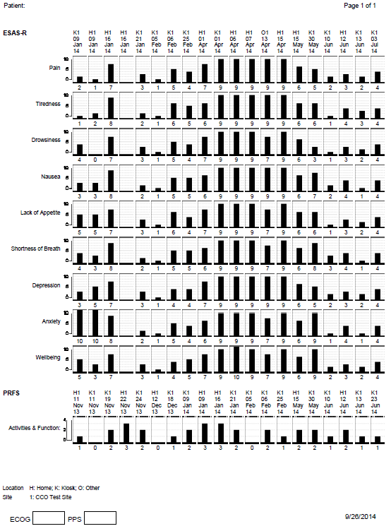

Reports Tab
This chapter instructs the Site Reports Admin on how to view reports in the ISAAC application. The ISAAC application has four types of reports: Integration, Kiosk Use, Notification, and Patient Registration Reports.
The column headings on the reports are sortable. The reports can be printed by clicking on the print icon, or printing the page with your browser. The reports can also be exported to XML, CSV, PDF, MHTML, Excel, TIFF, and Word formats.

Accessing Reports
To view a report:
- Click on Reports tab.
- Expand the Report type by clicking the button.
- Click on View.
Figure 19: Reports Tab with Expandable Report Types
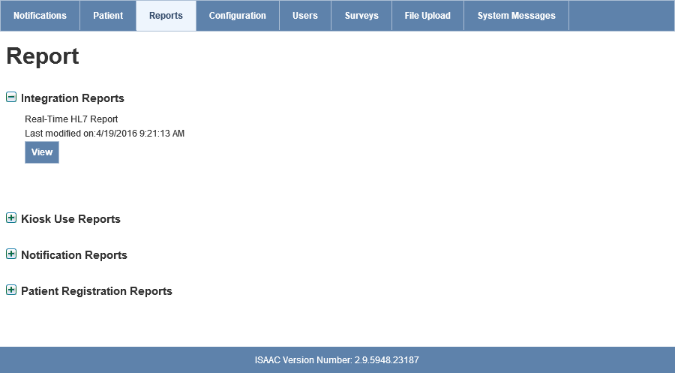
- The report is opened in a different tab or window. From the new window, you can complete your report selection criteria and then click on View Report.
- Some reports, such as Assessment Data Capture will require you to enter site/survey-specific information before generating the report.
- Click the button to export the report to one of the available formats and the button to print the report.

Report Breakdowns
The following is a breakdown of the three Report Groups and the reports within:

Integration Reports
    - Real-Time HL7: Shows a list of HL7 messages sent between the ISAAC application and hospital site. Includes direction, type, date, error details, and patient/survey identifiers. The purpose of the report is to monitor the live interfaces and support troubleshooting of integration issues when they occur.

Kiosk Use Reports
    - Survey Responses Entered at Kiosk: Shows a list of patients who used the Kiosk to enter their survey responses, the date, assessment time and the duration from the time the patient logged into ISAAC until they logged off.

Notification Reports
- Average Time for Closing Notifications Summary: Shows a list of sites or specific site with the summary of the average time for closing a notification each month for a specified year.

- Closed Notifications: Shows a list of closed notifications with number of days it was open.

- Facility Level Notifications: Shows a list of sites or specific site with number of remaining open notifications, closed notifications, and new notifications for a specified start date and end date

- Open Notifications: Shows a list of notifications open but not closed at a specific point in time.

- Total Number of Open Notifications Summary: Shows a list of sites or specific site with the total number of open notification each month for a specified year.

Patient Registration Reports
- Assessment Data Capture: Shows all submissions for a site and specified survey/date range.

- List of Patients by Disease Group: Shows patients by site with selected disease group.

- Patient Enrollment: Shows all individuals that have been enrolled at the selected site.

- Shared Patients: Shows which patients are registered at selected site and other sites.

- Tele-ISAAC Patients: Shows which patients are registered to use the home telephone version of ISAAC.

Configuration Tab
This chapter instructs the Site Admin on how to set their Site Configuration and the Kiosk Configuration settings.

Site Configuration
To set up your site configuration settings:
- Click on Configuration menu.
Figure 20: Site Configuration Settings
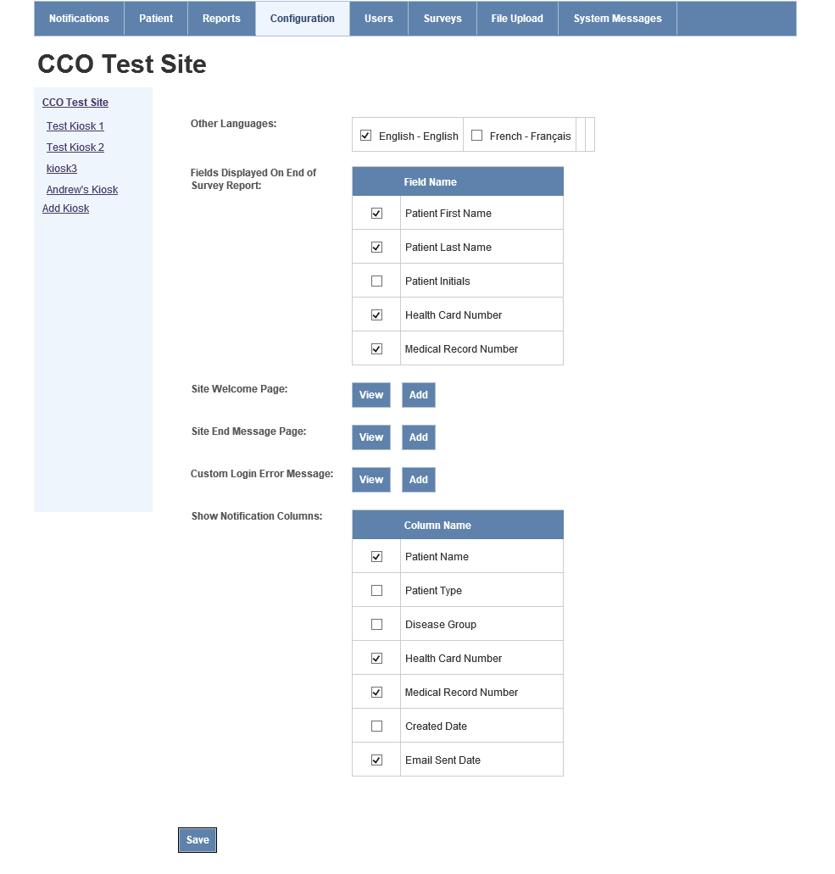
- Enable the Other Languages that you want available at your site.
- Enable the fields you want to be displayed on the End of Survey Reports (patient histogram printout).
Note: If the patient’s surname and first name are selected then patient’s initials should not be selected. In case all fields are selected then the system automatically chooses patients initials as default choice.
- Click on the Add button for Site Welcome page. The Site Welcome Message and Image page is displayed.
  - Select the language from the Language dropdown.
  - Enter your site message in the Site Welcome Message text area. You have to translate the text to the language you have selected.
  - Upload an image and then click on Save. The accepted file formats are JPEG, GIF, and PNG.
    - To abandon adding site welcome message, click the Cancel button and any pending changes will not be saved.
  - If you would like to edit your existing site welcome message then click on View.
    - Select the language from the Language dropdown.
    - Make your changes and click on Save.
    - If you want to delete the message and image then click on Delete.
Figure 21: Site Welcome Message configuration
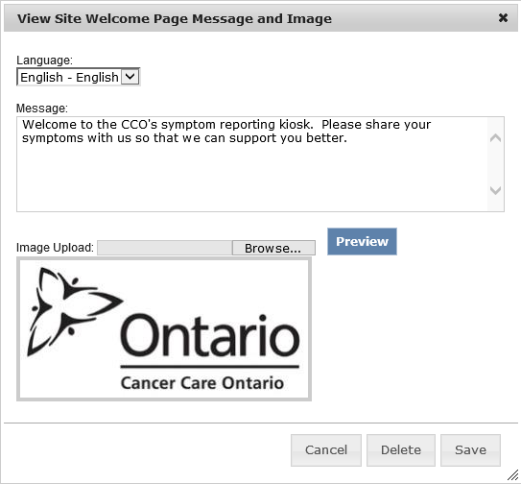
- Click on the Add button for Site End Message page. The Site End Message and Image page is displayed.
  - Select a language from the Language dropdown.
  - Enter your site message in the Site End Message text area. You have to translate the text to the language you have selected.
  - Upload an image and then click on Save. The accepted file formats are JPEG, GIF, and PNG.
    - To abandon adding site end message, click the Cancel button and any pending changes will not be saved.
  - If you would like to edit your existing site end message then click on View.
    - Select the language from the Language dropdown.
    - Make your changes and click on Save.
    - If you want to delete the message and image then click on Delete.
Figure 22: Site End Message Configuration
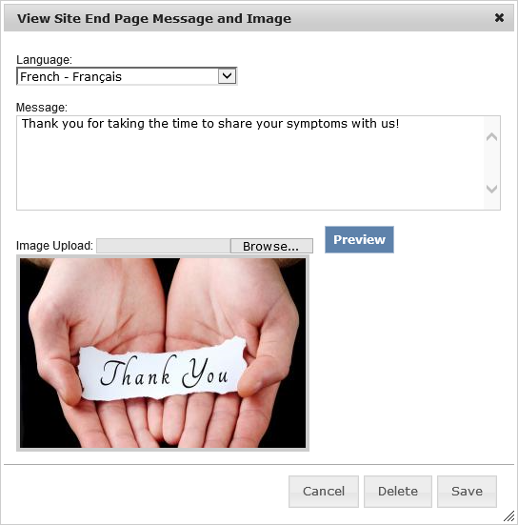
- Click on the Add button for Custom Login Error Message. The Add Site Custom Login Error Message page is displayed. This will allow the site to give the patient a customized error message upon a failed login to the kiosk.
  - Select the language from the Language dropdown.
  - Enter your site’s custom error message to display to patient when their login attempt at kiosk has failed. You have to translate the text to the language you have selected.
  - If you would like to edit your existing custom login error message then click on View.
    - Select the language from the Language dropdown.
    - Make your changes and click on Save.
    - If you want to delete the message then click on Delete.
Note: The Site Admin can also set kiosk-specific custom login error messages. The kiosk login error message will take preference over the site-specific login error message. If no kiosk or site error message is defined by the Site Admin, the CCO default patient login message will be displayed.
- For the Show Notification Columns, enable the columns that are hidden in the Notifications homepage.
- Click on Save.

Kiosk Configuration
To set up your Kiosk Configuration settings:
- From the Site Configuration page, click on the Add Kiosk link.
Figure 23: Add New Kiosk
- Checkmark the checkbox for Enabled. If the checkbox is blank, the kiosk is disabled.
- The Kiosk GUID is generated by the system. The Kiosk GUID is required by your IT support team to configure the kiosk device.
- Type the name of the kiosk in Name.
- Enable the surveys you would like to be displayed on this kiosk from the Survey List. ESAS-R and PFRS should always be enabled.
- Enable Notifications if you want triggered notifications to be sent from this kiosk. If checkbox is blank, then notifications from this kiosk are not logged and emails are not sent to recipients.
- Enable Print Supplementary Information from this kiosk. If checkbox is blank, then the supplementary information is not printed from the kiosk.
- Enable Print End of Survey Report from this kiosk. If checkbox is blank, then the End of Survey Report (Histogram) is not printed from the kiosk.
Figure 24: Kiosk Configuration
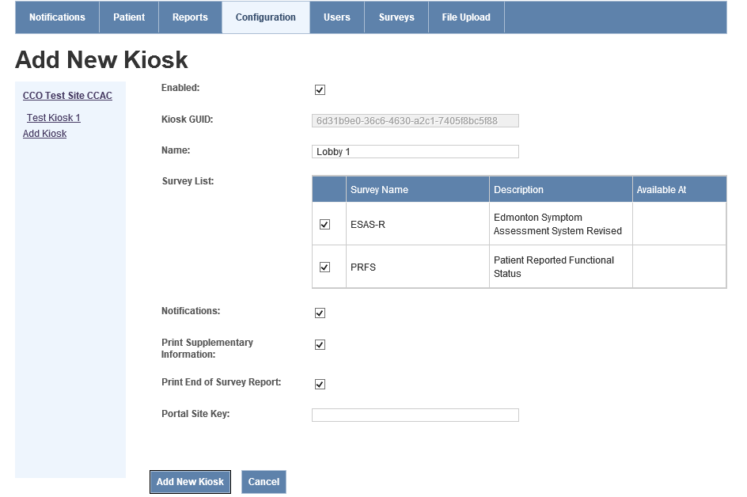
- Click on Add New Kiosk.
To duplicate the Kiosk Settings of an existing kiosk:
- From the Site Configuration page, select the name of the kiosk to duplicate from the menu on the left hand side.
- Click on the Duplicate button.
- The kiosk settings have been duplicated, a new Kiosk GUID is system generated and the user will have to type in a new name for that kiosk.
Figure 25: Duplicate existing kiosk button

Users Tab
This chapter instructs the Site Admin on how to create, edit and delete notification schedule exceptions for users. During the date range specified, the user will not receive notifications.
To create a notification schedule exception:
- Click on Users tab.
- Click on Add new record.
Figure 26: Add New Notification Schedule Exception
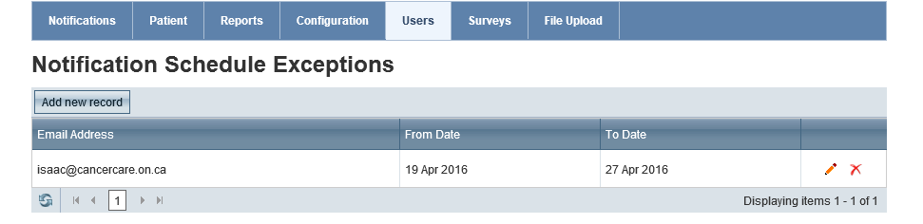
- Select an email address from the dropdown.
- Select a From and To date.
- Click on icon to save the record.
  - To abandon adding a new record, click the icon and any pending changes will not be saved.
To edit a notification schedule exception:
- Click on Users menu.
- Click on icon from the grid to edit the schedule exception.
- Change the From and To dates.
- Click on icon to save the changes.
  - To abandon editing a new record, click the icon and any pending changes will not be saved.
- To delete a notification schedule exception, click on the icon from the grid.
Figure 27: Editing Notification Schedule Exception

Survey Tab
The Survey tab allows Site Admin to view the surveys available to their site. The Survey Grid allows you to view the survey settings and to select a survey.
Figure 28: The Survey Tab Home Page
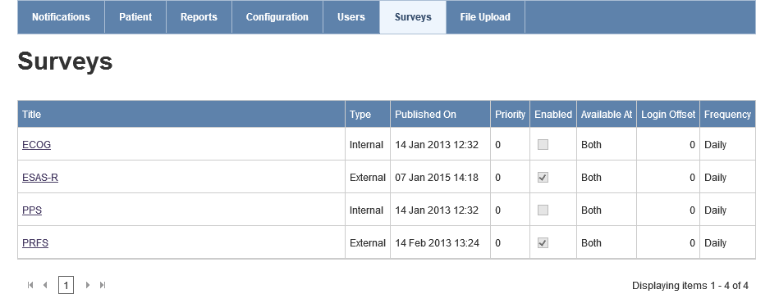

Survey Grid
These are the items displayed in the Survey Grid:
    - Title of the survey
    - Type of survey
    - Priority
    - Published on
    - Enabled
    - Available At
    - Login Offset
    - Frequency

Survey Status and Type
The survey status is seen underneath the survey tab when you have selected a survey name from the Survey Grid.
    - New: is displayed at the create survey page.
    - Edit Unpublished: is displayed when the survey has been added from the create survey page, but not yet published.
    - Published: is displayed when you publish the survey.
    - Edit Published: is displayed when you go into a published survey to change settings.
There are two survey types:
    - An External survey is created to be completed by patients at the patient application level. All tabs must be completed.
    - An Internal survey is created for the Patient Registrants to complete. The internal surveys are not displayed to the patients. When creating an internal survey you will complete the Survey General, Question General, Questions Precondition, and Survey Summary tabs.

Survey General Tab
To edit survey settings, click on the survey name from the Survey Grid:
- The Survey General tab is displayed. The status of the survey is Edit Published.
- Display Survey Title allows you to enable the survey title to be displayed on the question pages at the patient application level. If the checkbox is blank, then the survey title is not displayed on all pages.
- Display Page Numbers allows you to enable the page numbers to be displayed on all question pages at the patient application level. If the checkbox is blank, then the page numbers are not displayed.
- Send HL7 Message From allows sites configured to receive HL7 to specify whether HL7 messages should be sent for surveys completed from a kiosk, home, or both (to be set by a CCO Admin).
- Priority allows you to decide the order in which this survey is displayed to the patient. Click on the Priority text box to enter a digit. If you input 0, then this is the first survey that is displayed to the patient when logging into the ISAAC application.
Note: When two surveys have the same priority then the surveys are displayed based on the survey creation time. For example, you can have two surveys with priority level as 0 but the survey created on May 24, 2012 12:00 a.m. will be displayed before the other survey created on May 24, 2012 8:00 a.m.
- The items in the grid can be set by both the CCO Admin and Site Admin. If CCO Admin would like the Site Admin to create these settings for their site then there is a checkmark in the checkbox called Configurable by Site. These are following items in the grid:
- End of Survey Report allows you to hide or show the End of Survey Report for this survey. To enable the End of Survey Report, the checkbox should have a checkmark. If the checkbox is blank, the End of Survey Report is disabled.
- Enabled allows you to turn the survey on and off, which means if it is turned on then the patients can complete this survey once it is published. To enable a survey, the checkbox should have a checkmark.
- Login Offset allows you to set at what login this survey will be displayed for the patients to complete. For example, if you set the login offset as 6 then the survey will be displayed to the patient at their 7th login. The login offset starts from 0.
- Available At allows you to set up where this survey can be completed. You can choose one of the following from the dropdown:
  - Clinic Electronic stands for kiosk.
  - Home Electronic stands for Internet Browser.
  - Both allow the survey to be completed from Clinic Electronic and Home Electronic.
- Frequency allows you to set up how often the patients need to take the survey. You have the option of selecting from: daily, weekly or monthly.
- Click on the Save button.
Figure 29: The Survey Details Page
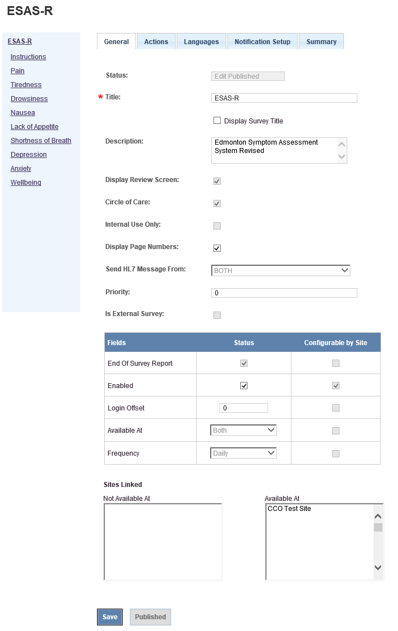

Survey Actions Tab
This section instructs the Site Admin on how to attach additional surveys and/or supplementary information documents to your survey.
Note: Only published surveys and PDF file format for Supplementary Information can be attached.
To attach additional surveys:
- Click on a survey from the Survey Homepage. You are taken to the Survey General Tab.
- From there, click on the Actions Tab.
- Select the question from the If dropdown and then choose the choices from the Contains list box that will trigger the additional survey to be displayed after the completion of the survey. For example, you want Pain Management survey to be displayed if the patient answers 8, 9 or 10 for Pain. You select Pain from the drop down and choose choices 8, 9 and 10.
- Click on Action drop down to select Display Another Survey.
- Click on Display Survey After Survey is Completed drop down and select a survey.
- Click on Save. The action is displayed in the Existing Actions Grid.
- To change your existing actions, click on the question and then change your choices from the list box. Click on Save.
- If you want to delete the Action then you click on icon in the Existing Actions Grid.
Figure 30: Actions Display Another Survey
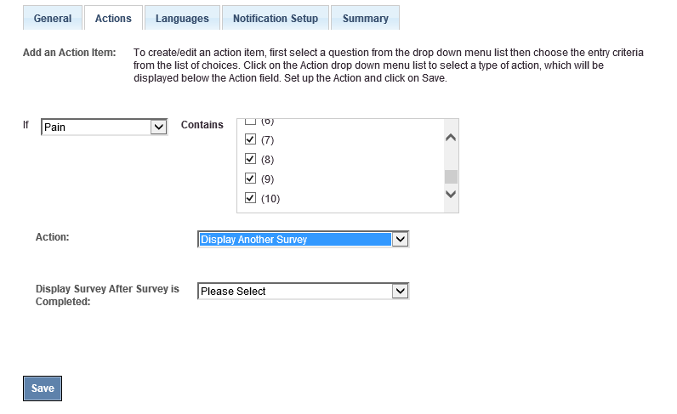
To attach a supplementary information document:
- Click on a survey from the Survey Homepage. You are taken to the Survey General Tab.
- From there, click on the Actions Tab.
- Select the question from the If dropdown and then choose the choices from the Contains list box that will trigger the supplementary information to be attached. For example, you want Pain Management information guide to be displayed if the patient answers 8, 9 or 10 for Pain. You select Pain from the drop down and choose choices 8, 9 and 10.
- Click on Action drop down to select Display Supplementary Info.
- Attach a file and then click on Save. The action is displayed in the Existing Actions Grid.
- To change your existing actions, click on the question and then change your choices from the list box. Click on Save.
- If you want to delete the Action then you click on the icon in the Existing Actions Grid.
Figure 31: Add Supplementary Information
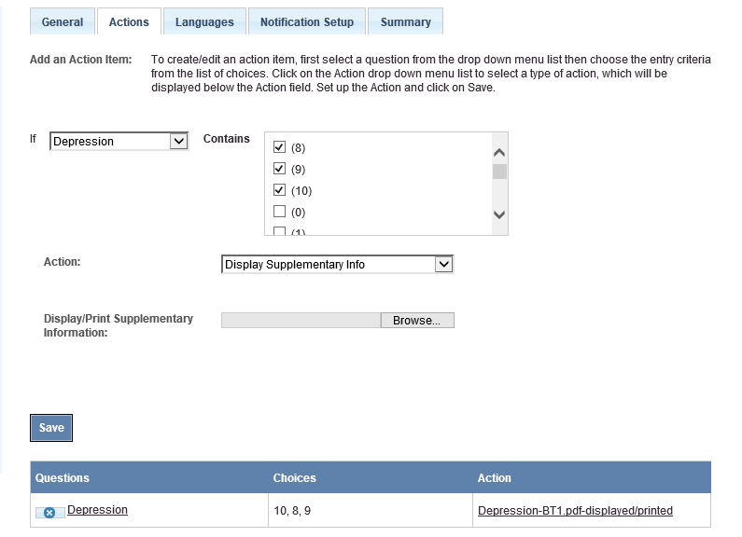

Survey Notification Setup Tab
This section instructs the Site Admin on how to create notification schedules for recipients and to grant permissions to users to close notifications.
To create a notification schedule for recipients:
- Click on a survey from the Survey Homepage. You are taken to the Survey General Tab.
- From there, click on the Notification Setup Tab.
- Click on a notification threshold Question hyperlink from the Existing Notifications Grid.
Figure 32: Notification Setup Tab
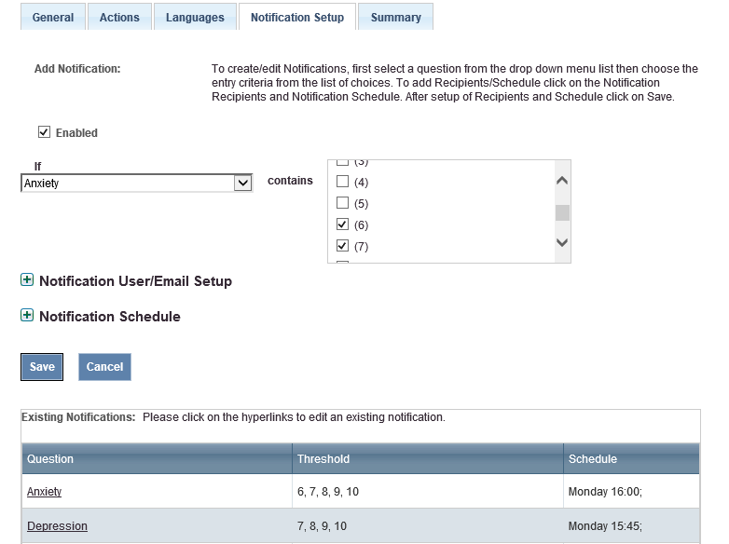
- Expand Notification User/Email Setup. Click on Add new record.
- To grant permission to user to close notifications for the selected question, select the Close checkbox and select the user from the Username dropdown.
- To enable e-mail notifications, select the Email checkbox and then enter the Email Address.
Figure 33: Notification User/Email Setup
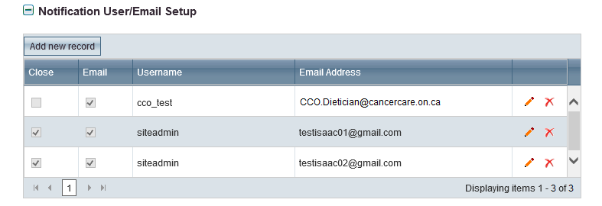
- Click on icon to save the record or to abandon notification setup without saving.
- Once the notification has been saved, you can edit the user setup by selecting the button.
- Expand Notification Schedule. Enable the location where the notifications are received from by selecting the following: Clinic Electronic (kiosk), Home Electronic (browser) and Tele-ISAAC.
- You can select what time the notification email is send to the user by choosing either Send Notification immediately (which would be immediately when the notification is triggered) or as a summary at a certain time by selecting Create Notification Schedule.
- Click on Save. The notification is displayed in the Existing Notifications Grid.
Figure 34: Notification Schedule Setup
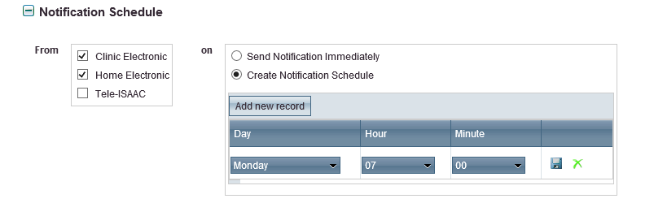
- To change your existing notification, click on the question and then edit the Notifications User Setup and Notification Schedule. Click on Save.
  - To abandon creating a new notification, click the Cancel button and any pending changes will not be saved.
Note: You cannot delete a notification or create more than one notification schedule for the notification threshold.

Survey Summary Tab
This section displays the order of the questions to the Site Admin. Click on the Summary tab to view the order of the questions in the survey. It will display the survey’s question titles, description and answer types as well.
Figure 35: Summary Tab
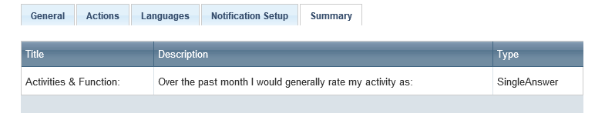

File Upload Tab
This chapter instructs the Site Admin on how to upload files, view search history, and download survey and patient registration templates.

Upload File
To upload a completed file template:
- Click on the File Upload menu. The Upload File tab is the default.
- Select Upload File Type from the dropdown.
- Browse for file and click on Upload. User will automatically be moved to the File Upload Status tab.
Figure 35: File Upload Tab
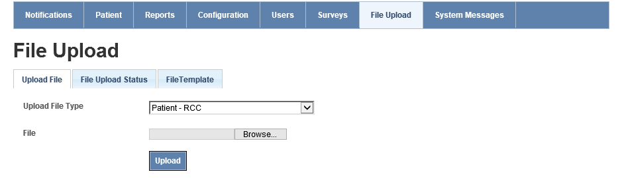

File Upload Status
The File Upload Status tab can be used to view the status of the File Upload or to search File Upload history.
- While file upload is being processed, the user will automatically be moved from the Upload File tab to the File Upload Status tab.
- During upload, the Upload Status in the Search Results grid will read In Progress. Click the Refresh button to update the status.
Figure 37: File Upload Status
- Once the file upload is complete, the Upload Status column will be updated to Completed, Errors, or Warning.
Figure 38: File Upload Status with Refresh
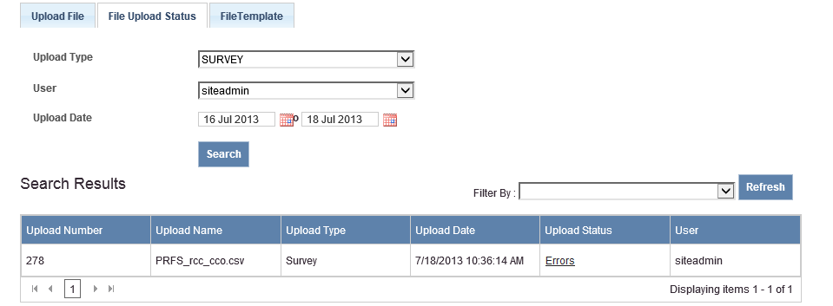
- To view details of the status, click on the Errors or Warning hyperlink under Upload Status. The Log Report state the error and recommended course of action for you to take.
Figure 39: Log Report
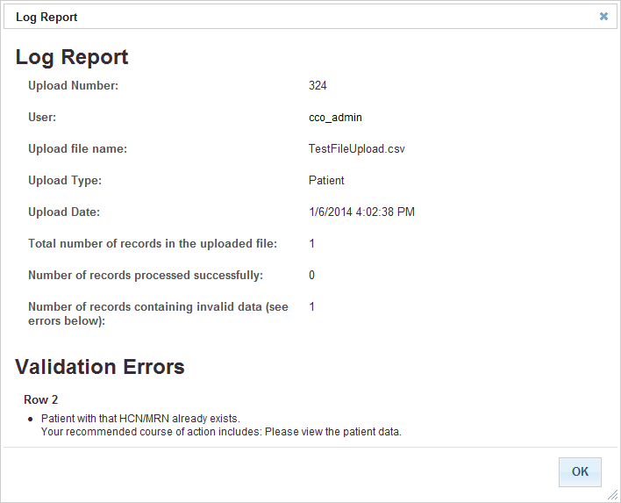
To search for File Upload history:
- Select the Upload Type and/or User from the dropdown.
- Select an Upload Date range from and to.
- Click on Search. The results are displayed in the Search Results grid below.
- You can filter the search history by warnings, errors and both.

File Upload Error and Warning Messages List
The following is a list of the possible File Upload Error and Warning messages:
- System didn't set up template correctly for this upload file. Please contact administrator.
- {0} input data format is not correct. It should be an integer value for month ({1}).
- {0} input data format is not correct. It should be 4 digit integer value for year ({1}).
- {0} input data format is not correct. It should be datetime format as {1}.
- {0} is a mandatory field, please input data into this field.
- Survey without a specific question.
- Input question answer {0} is not correct. System doesn't have this choice value for question {1}.
- Question {0} is mandatory. Please input your answer to this question.
- System doesn't have questions associated with current survey or the survey template doesn't setup correct question ID for this column data.
- {0} column definition is not correct, please contact administrator.
- Birth Year: {0}; Birth Month: {1}; Birth Day: {2}
- Internal system exception. Please contact administrator. Exception detail: {0}
- Input birthday Year, Month, Date values are not correct.
- OHIN or MRN is not correct, system cannot find the patient.
- The specified patient is not in current site (Site ID: {0}).
- Assessment location {0} cannot be found.
- Patient with same Patient Chart Number and Health Card Number already exists in database.
- Internal system exception for data validation. Please contact administrator. Internal exception as follows: {0}
- File data in row: {0} cannot import to database.
- Patient Type: {0} does not exist.
- Disease Type: {0} does not exist.
- System cannot get insurance types. Please contact administrator to check database.
- System cannot get any available survey responses from the uploaded survey file.
- System raised exception when generating temporary password for patient: {0} {1}. Please contact with administrator.
- Assessment date {0} should not be later than today.
- Survey with survey ID {0} didn't set frequency (such as daily, weekly, monthly) for site with site id {1}.
- Specified site with site ID {0} didn't assign to this survey.
- The uploaded file has more than {0} records, but the system only allows an import maximum of {1} records each time.
- There are {0} columns in the file. The system requires data with {1} columns.
- {0} input data format is not correct.
- {0} input data format is not correct. It should be an integer value for day ({1}).

File Upload Template
To download a File Template:
- Click on the File Upload menu.
- Click on File Template tab.
- Select a template from the Template Name dropdown.
- Click on Download.
  - To abandon downloading a file template, click the Cancel button and any pending changes will not be saved.
- Downloaded template is in CSV file format.
See the Symptom Management Section of Cancer Care Ontario’s Data Book for data element details including formats and valid values.
Figure 40: File Upload Template Download
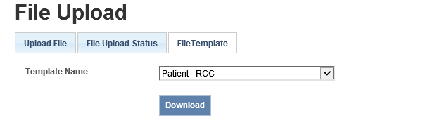

Helpdesk
This chapter informs you on the type of assistance available in the ISAAC application.

Help Page
If you require ISAAC resources or information materials, click on the Help link. The Help page is indexed, categorized and searchable. If you know the type of document you are looking for then search can help you locate the document.
Figure 41: The Help Page
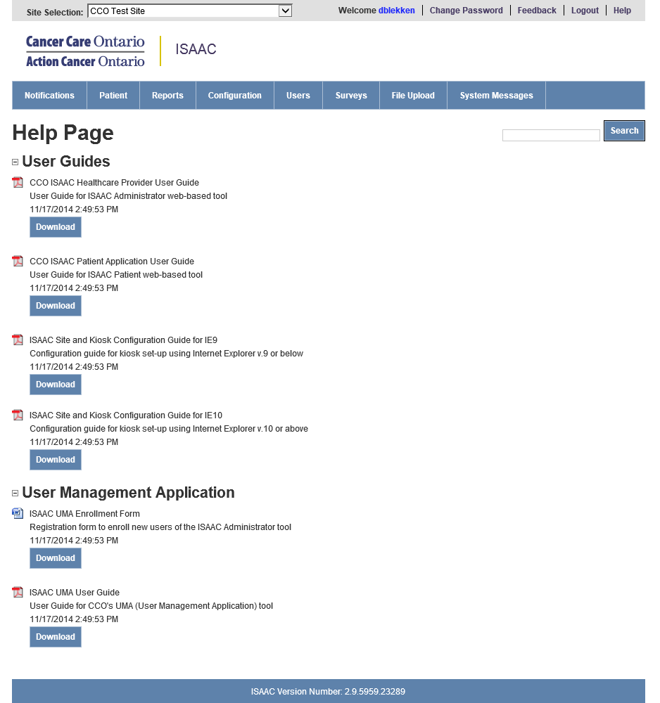

Feedback Tab
You can communicate with the ISAAC helpdesk by clicking on the Feedback hyperlink. This will send an email to ISAAC@cancercare.on.ca.
Figure 42: The Feedback Link
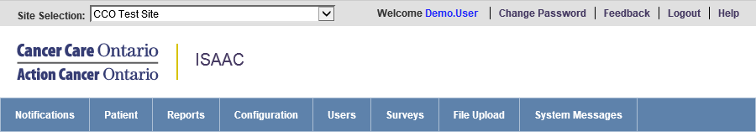

Appendix A: Version History

Document History
Revision | Type | Revision Date | Revised By | Revision Details
0.1 | Draft | May 21, 2012 | Farah Hafeez | Initial Draft
0.2 | Draft | May 30, 2012 | Farah Hafeez | Added Screenshots
0.3 | Draft | July 10, 2012 | Peter Drinkwater | Added feedback from CCO
0.4 | Draft | September 17, 2012 | Peter Drinkwater | Added feedback from CCO
0.5 | Draft | January 5, 2013 | Maria Illek | Edits
0.6 | Draft | January 14, 2013 | Maria Illek | Updated screenshots
1.0 | Final | March 25, 2013 | Maria Illek | Updated reset password section
1.1 | Final | April 22, 2013 | Maria Illek | Added reference to Data Book under File Upload section
1.2 | Final | January 7, 2014 | Elise Poupard | Edits for ISAAC Release 2.7
1.3 | Final | April 26, 2016 | Daniel Blekkenhorst | Updated CCO Branding and Screenshots for ISAAC Web Refresh Project and HL7 Report

Appendix B: List of Figures
Below is the list of each screenshot contained in the document. For reference, you can use the page number to find the figure or if you are using an electronic version of the guide, you can link directly from the line item below.
Figure 1: The Password Change Link 6
Figure 2: Paging Through Grids 7
Figure 3: Sorting Through Grids 8
Figure 4: Inline Editing 8
Figure 5: Mandatory Field Indicators 9
Figure 6: Left Navigation Tool 9
Figure 7: Expand and Collapse Functions 10
Figure 8: Multi-Site Selection Dropdown 10
Figure 9: The Notification Tab Home Page 11
Figure 10: Patient Search Feature 12
Figure 11: Patient Enrollment Form 13
Figure 12: Edit Patient Demographics 14
Figure 12: View Survey Responses 15
Figure 14: Survey Responses Popup 15
Figure 15: Add or Edit Survey Responses 16
Figure 16: Delete or Resend Survey Responses 17
Figure 17: View End of Survey Report 18
Figure 18: End of Survey Histogram Report 19
Figure 19: Reports Tab with Expandable Report Types 20
Figure 20: Site Configuration Settings 22
Figure 21: Site Welcome Message configuration 23
Figure 22: Site End Message Configuration 24
Figure 23: Add New Kiosk 25
Figure 24: Kiosk Configuration 26
Figure 25: Duplicate existing kiosk button 26
Figure 26: Add New Notification Schedule Exception 27
Figure 27: Editing Notification Schedule Exception 27
Figure 28: The Survey Tab Home Page 28
Figure 29: The Survey Details Page 30
Figure 30: Actions Display Another Survey 31
Figure 31: Add Supplementary Information 32
Figure 32: Notification Setup Tab 33
Figure 33: Notification User/Email Setup 33
Figure 34: Notification Schedule Setup 34
Figure 35: Summary Tab 34
Figure 35: File Upload Tab 35
Figure 37: File Upload Status 35
Figure 38: File Upload Status with Refresh 36
Figure 39: Log Report 36
Figure 40: File Upload Template Download 38
Figure 41: The Help Page 39
Figure 42: The Feedback Link 40

