Cancer Care Ontario (CCO) ISAAC Application

Patient User Guide
Version 1.3
Last Updated: Feb 2016

User Guide Table of Contents
This package is intended to be available to patients at facilities that have implemented the ISAAC application in their clinics. This guide provides detailed information on the CCO ISAAC web application’s Patient Portal with respect to the features and functionality offered. Included is an overview of the following:
About This Guide 3
Overview 3
Glossary 3
Audience 3
Organization 3
Background 4
ISAAC Overview 4
Accessing the ISAAC Patient Portal 5
Overview 5
Patients at Cancer Centre Kiosks 5
Patients at Home 7
Translations to Other Languages 9
Overview 9
Selecting French Language 9
Additional Languages 10
The Terms of Use Page 11
Overview 11
The Site Selection Page 12
Overview 12
Completing a Survey 13
Overview 13
Completing your Survey 13
Reviewing your Answers 15
Completing Additional Surveys 16
Overview 16
Current ISAAC Surveys 16
Printing the End of Survey Report 17
Overview 17
Kiosk 17
Home 17
Reading the Report Contents 18
Supplementary Information 19
Overview 19
Kiosk 19
Home 19
Logging Off and Quitting 20
Overview 20
Logout before Survey Completion 20
Automatic Logout for Idle Sessions 20
Helpdesk and Error Messages 21
Overview 21
Error and Warning Messages 21
Appendix A: Version History 22
Document History 22
Appendix B: List of Figures 23

About This Guide

Overview
This guide outlines the features and functionality of the ISAAC Patient Portal for the use of patient users. Content is outlined with descriptions, figures and screenshots to facilitate a better understanding of the application. The Admin portal and UMA web portal are outlined in other guides.

Glossary
The following terminology is used within this guide:
Term | Definition
CCO | Cancer Care Ontario
CPAC | Canadian Partnership against Cancer
EPIC-CP | Expanded Prostate Cancer Index Composite for Clinical Practice
ESAS-R | Edmonton Symptom Assessment System-revised
iPEHOC | Improving Patient Experience and Health Outcomes Collaborative
ISAAC | Interactive Symptom Assessment and Collection
PHI | Patient Health Information
PREMs | Patient-reported experience measures
PROMs | Patient-reported outcome measures

Audience

ISAAC Users (Patients, Caregivers, etc.)
This guide outlines content from only the Patient portal. It will assist users in achieving a deeper understanding of the features of the tool.
Clinical users may also find value in the guide for training and testing purposes.

Organization

Table of Contents
Outlines the overall structure and content of this document and is hyperlinked for easy navigation to chapters or sections within the guide.

Chapters
Each chapter groups related information and is likely to have multiple sections and hyperlinks to other sections within the guide, as well as to external reference material in the ISAAC Implementation Toolkit.

Background

ISAAC Overview
An extensive body of literature shows that cancer and its treatment negatively impact the physical, psychosocial and existential-spiritual domains of patients’ health. Patients tend to under-report their symptoms in conversations with clinicians and symptoms are under-recognized and under-treated. Additionally, patients report a low quality of support for activation in self-management of their symptoms. Combined, these issues result in a gap of clinical management which can lead to significant physical and psychological morbidity, negative consequences for quality of life and possibly mortality. Healthcare costs are expected to escalate in coming years, with an increasing incidence of cancer and a burgeoning survivor population living with cancer as a chronic disease.
Globally, the use of patient-reported data is now a health system imperative to ensure early and efficient detection of these problems, to evaluate the effects of interventions on health outcomes and to monitor the quality of care from the patients’ perspective. The main tools advocated for capturing the patients’ perspectives about the effects of cancer and its treatment are: (1) patient-reported outcome measures (PROMs), which measure the impact of an illness and effects of interventions (e.g. quality of life, symptom severity, functional status, health status); and (2) patient-reported experience measures (PREMs) that capture patients’ views of what happened during the health encounter (i.e. processes of care), as a metric for quality of care or service performance.
Cancer Care Ontario’s (CCO) Interactive Symptom Assessment and Collection (ISAAC) tool allows patients to assess and monitor their symptoms through an easy to use, standardized, secure, web-based application. ISAAC allows patients to complete survey assessments electronically on a touch-screen kiosk at their local cancer centre, or from the convenience of their Internet-linked home computer or mobile device. The assessments are then reviewed by the patients’ care team which allows symptoms to be managed more effectively and facilitates appropriate care planning. Clinicians can access their patients’ symptom information, regardless of where the patient has entered their scores and can track this information over time.

Accessing the ISAAC Patient Portal

Overview
ISAAC’s patient portal is available from two main channels. The first channel is the ISAAC Kiosk. ISAAC Kiosks are available at the regional cancer centres and their satellite sites. The second channel is ISAAC Home. The Home channel as a web portal includes a webpage that you can navigate to from your computer or mobile device’s internet browser.
Please Note: You must have been enrolled into the ISAAC application before you can login. Please talk to staff or volunteers if you have trouble logging into your account.

Patients at Cancer Centre Kiosks
Patients visiting ISAAC supported centres will have access to configured computers, kiosks, or tablets in the waiting room of the centres where all that is required is to login before you can start recording your symptoms. When completing the survey at a kiosk, you will see the following two pages:
- The Kiosk Welcome Page: this page can be modified by a site to include a Site Welcome message, and an image to accompany the message. The page allows you to log in by swiping your Ontario Health Card using the health card reader (if available) or click the button to advance to…
- The Kiosk Login Page, which allows you to manually enter your Ontario Health Card or Medical Record Number.
To login at the kiosk:
- If you are in a centre with a Card Reader, it will be indicated near the kiosk. Swipe your Ontario Health Card using the health card reader. If your Ontario Health Card is read correctly then the ISAAC Terms of Use Page is displayed and you will have been logged in. If you are unable to locate the health card reader, please ask your hospital helpdesk for assistance.

- If the system cannot read your Ontario Health Card or if you would like to type your Ontario Health Card Number or Medical Record Number then click or touch the Please swipe your Ontario Health Card Number or touch here to begin button. This displays the Kiosk Login Page.

- On the Kiosk Login Page (shown in Figure 2, on the next page), use the keyboard to type your Ontario Health Card Number then touch Continue. If you make a mistake when typing your Ontario Health Card, please touch Clear and then re-enter your Ontario Health Card Number.

Figure 1: The Kiosk Welcome Page
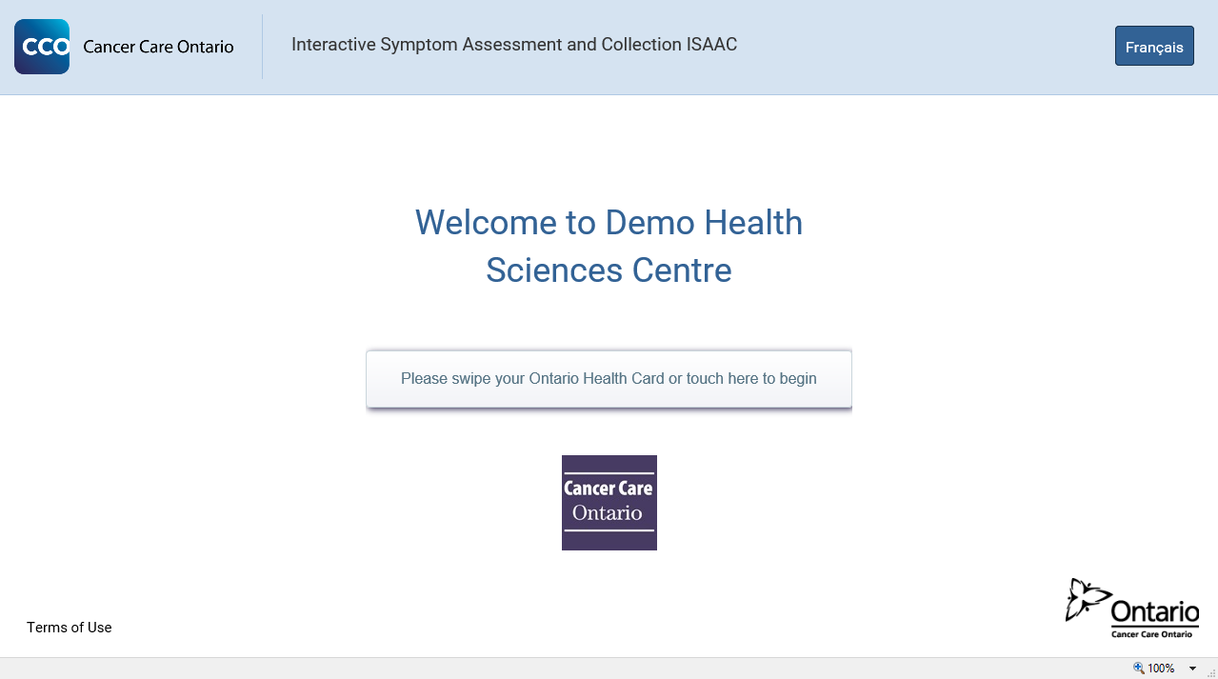
Figure 2: The Kiosk Login Page
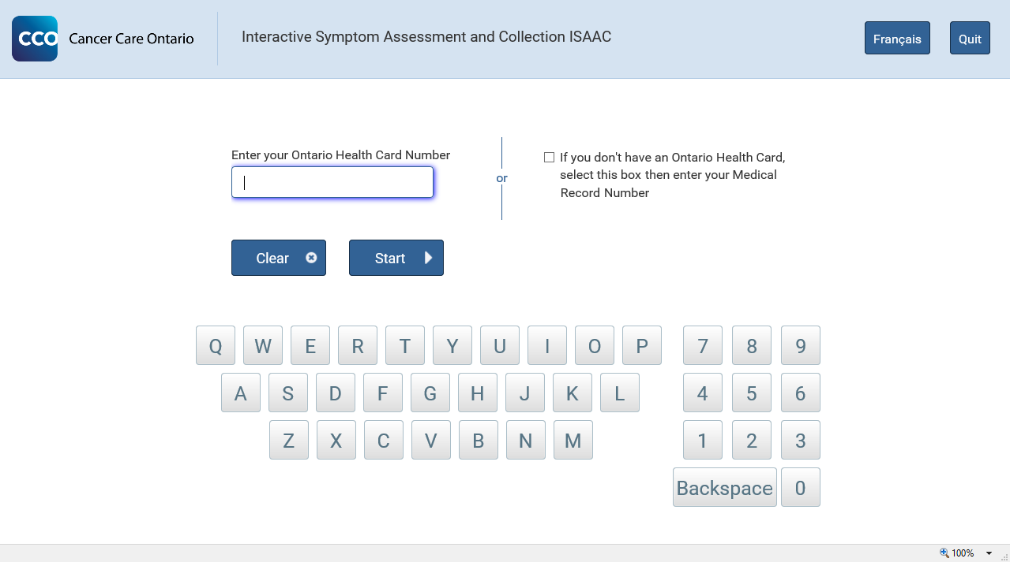
- If you would like to log in using your Medical Record Number, touch the checkbox I do not have an Ontario Health Card Number. You will now be asked to enter your Medical Record Number.

Figure 3: Login Page Health Card Number to Medical Record Number Selection
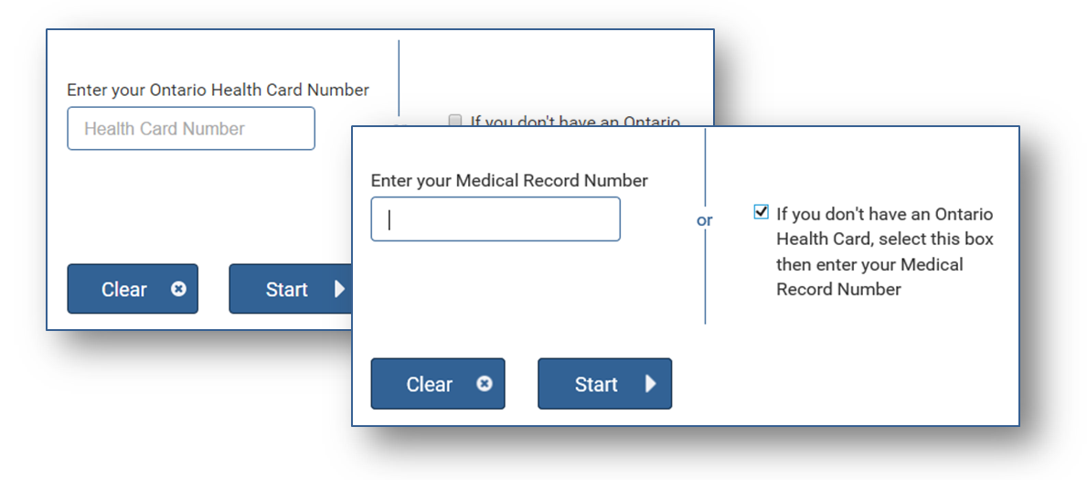
- Use the keyboard to type your Medical Record Number and then touch Continue. If a mistake is made in entering your Medical Record Number, please touch Clear and then re-enter your Medical Record Number.

Patients at Home
Instead of using the ISAAC Kiosk at your hospital, you can access ISAAC from any computer or home device with an internet connection. ISAAC has been designed to be responsive. Responsive web pages will scale between your different devices and ensure that you have a suitable experience whether you have accessed ISAAC from your computer, phone, tablet, or iPad. ISAAC is also compatible with each of the main internet browsers (Internet Explorer, Firefox, Chrome, and Safari).
To reach the ISAAC login page, connect to the internet and launch your internet browser and enter the following URL in the address field:
isaac.cancercare.on.ca
If you are uncomfortable entering website addresses you can search “isaac cancercare” into Google or your internet search engine and click on the first link.
Figure 4: Internet Search for the ISAAC Login Page
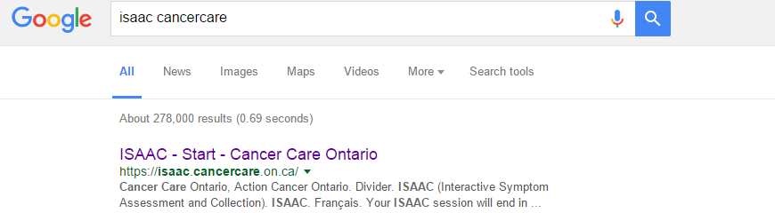
The URL should load the ISAAC Home Login Page as seen below where you can login to ISAAC.
Figure 5: The ISAAC Home Login Page
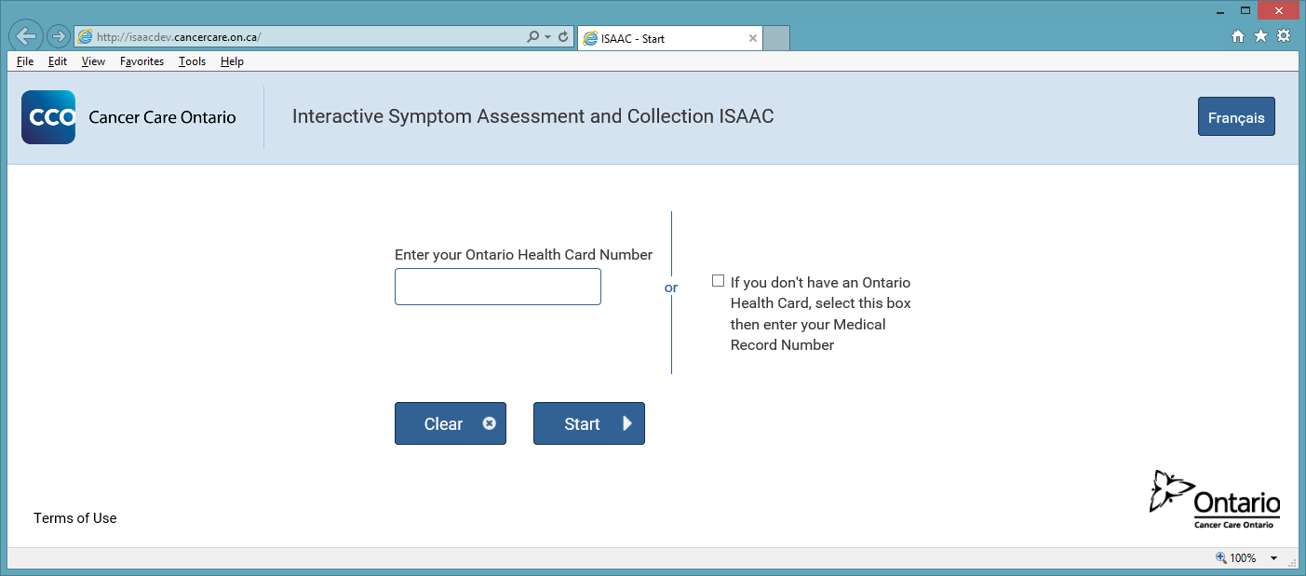
Type in your 10-digit Ontario Health Card Number. Click on Start to log in. If an error is made in entering your user ID or password, please click on the Clear button to re-enter your Ontario Health Card Number. If you would like to log in using your Medical Record Number, click on the checkbox: If you don’t have an Ontario Health Card, select this box then enter your Medical Record Number. Click on Start to log in.

Translations to Other Languages

Overview
This section shows you how to change the language settings for your survey session. You can change your language settings from any page of the ISAAC application.
Please note that when you change the language, this selected language is saved for your next survey. This means that next time you log into the ISAAC application, the survey will be displayed in your last selected language. For example, say you login to ISAAC application from the kiosk at Princess Margaret Hospital and change your application language to French. You complete your survey in French and finish. The next time you log into ISAAC for the Princess Margaret Hospital site, the prompts will be displayed in French.
However, if the application or survey is not available in your selected language then the application or survey will be displayed in English.

Selecting French Language
To select French for your session:
- Click on Français button in the top right-hand corner.
- The application content is changed and displayed in French.
This preference will be saved for each time you use ISAAC. If you would like to switch back, the button will have been replaced by an English button. The button will be available on each webpage.
Figure 6: The French Translation Button
Figure 7: The French Translation of the ESAS Instructions Page
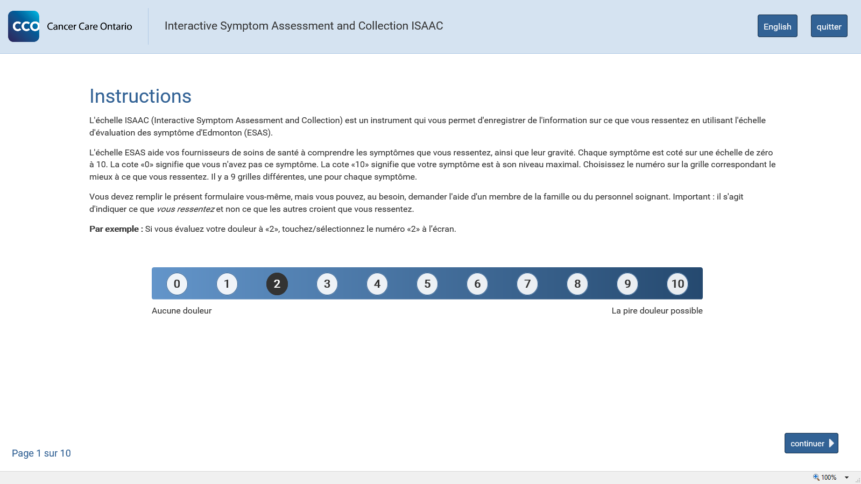

Additional Languages
Currently ISAAC only offers translations for English and French. If you would like to complete your ESAS or PRFS assessments in another language, please ask for support from the centre’s staff or volunteers as they may have a paper version in the translation you prefer. Printable translations for many languages are located on the Cancer Care Ontario website:
http://www.cancercare.on.ca/cms/one.aspx?portalId=1377&pageId=58189

The Terms of Use Page

Overview
The Terms of Use Page is displayed the first time you log into the application either from the internet browser or at the kiosk. After you have accepted the Terms of Use, you can log into the application to complete your survey assessments. The Terms of Use are only displayed once, unless the terms have been changed since you accepted them. In that case, the new Terms of Use will be shown to you to accept.
Please Note: You can view the Terms of Use anytime from the Patient Welcome Page or Survey Review Page.
Figure 8: The Terms of Use Page
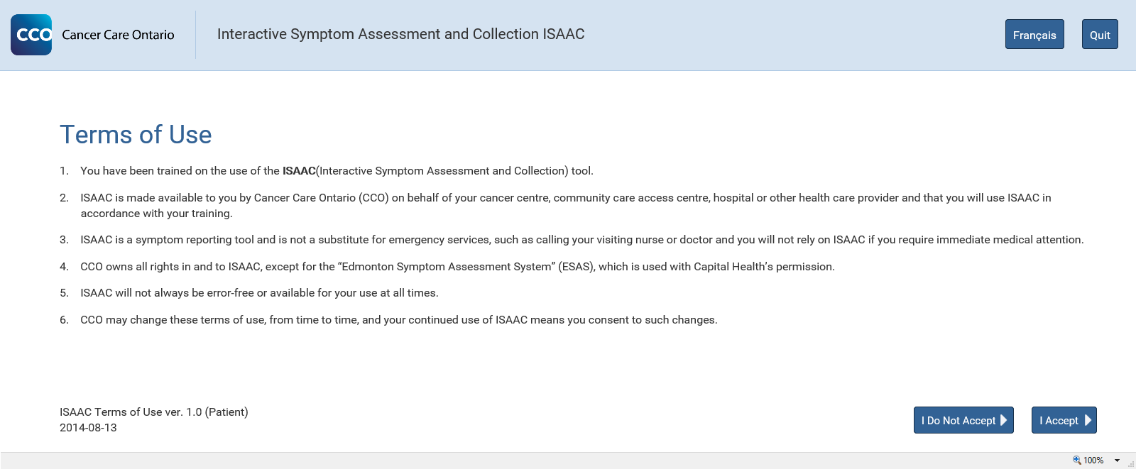

The Site Selection Page

Overview
The Site Selection Page is displayed when you log into ISAAC if you are attached to more than one site. This may occur if you have completed ISAAC at more than one centre. This page is only available from the Home view. You can select a site from the drop down. Once you make the selection, your survey responses during this login are sent only to the site you have selected. Click Continue and you will be able to begin your surveys.
Figure 9: The Site Selection Page
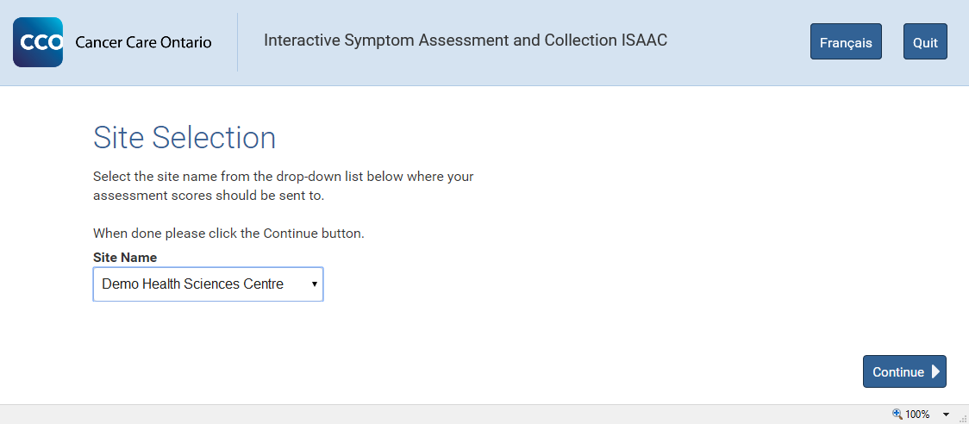

Completing a Survey

Overview
This chapter explains the process of completing a survey. Typically surveys will begin with an instructions page and include different questions on each page that follows. After you have answered all questions in the survey, you will be provided with a summary where you can review and submit the survey.

Completing your Survey
- Generally, an instructions page is displayed that tells you about the content and purpose of the survey. It gives you instructions on how to complete that survey.

- After you read the instructions, click on Continue. You will be directed to the first survey question.
Figure 10: The Survey Instruction Page
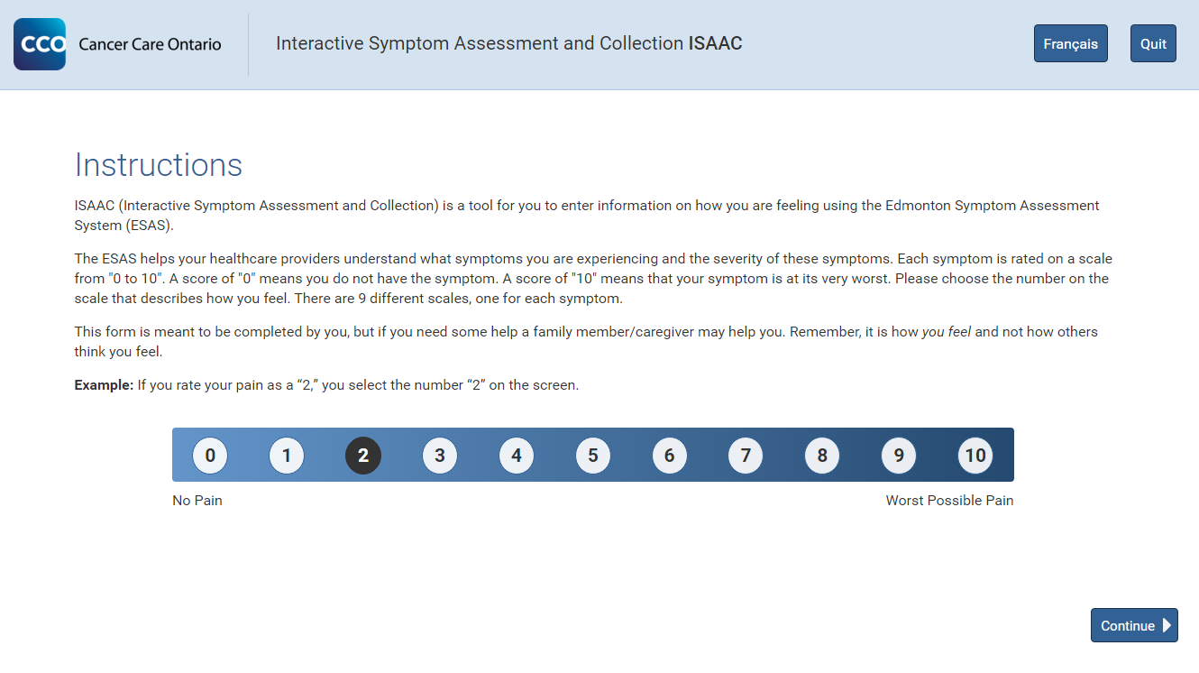
- Read the question carefully. You can then select your answer and click on Continue to get to the next question (Some questions may be mandatory and the Continue button will become enabled only after you have selected an answer).

- Follow the above process for all questions.
- If you need to go back to change your answer for a previous question, you can click on the Go Back button.
Figure 11: The Survey Question Page
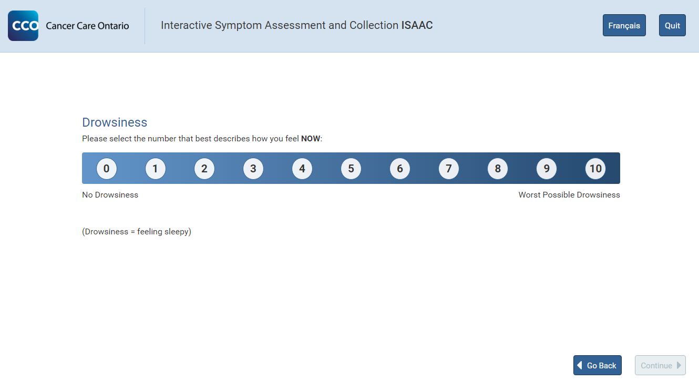
- When you have answered the last question, and you click Continue, you are taken to the Review Page.

Reviewing your Answers
This section shows you on how to change your answers from the Review page. The page shows a summary of your answers to all questions for the current survey. This page is displayed after you have answered the last question of a survey. From this page, you can check your selections and change your answers by clicking on the question.
Figure 12: The Survey Review Page
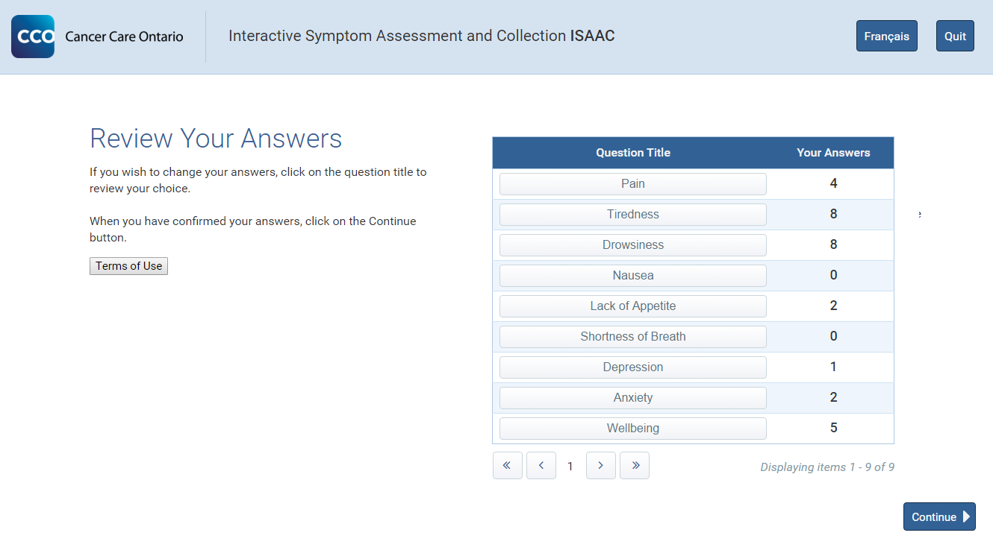
- To change your answer to a particular question, select the question title and you will be taken back to that Question Page.
- Once you change your answer, click on Continue. You will then be taken back to the Review page.
- When you are satisfied with your answers, select Continue (if you have more surveys to complete, you will be brought to the start of the next survey) or Done (if you are completing your final survey) from the Review Page to submit your survey responses.
Please Note: If you do not click on the Continue or Done button your survey responses will not be saved for that survey. When you click the button, you will see the following hourglass image. ISAAC is confirming and saving your answers to the system for the survey you have just completed.

Completing Additional Surveys

Overview
Additional surveys may be displayed based on your answer to a question in the current survey. This means that while you are taking a survey, another survey may be added to your list of surveys to be completed based on your answers to a question or questions. The additional survey, if required, is presented to you after you have completed your current survey. When you have completed the final survey available to you, the button on the Review Page will say Done.

Current ISAAC Surveys
The surveys that will appear are configured by the cancer centre and may vary based on the last time you completed the survey, whether you are completing the survey in the centre, or are completing surveys from a personal, home device.
The surveys you will most frequently see are the ESAS-r and PRFS surveys which assess the degree of impact from physical and mental symptoms at a high level. There are nine Edmonton Symptom Assessment System - Revised (ESAS-r) survey questions which cover pain, anxiety, appetite, etc. The Patient Reported Functional Status (PRFS) survey asks a single question in regard to your ability to complete day to day tasks. ISAAC will allow you to complete these surveys once per day from home or from cancer kiosks.
A small number of cancer centres are piloting additional assessments such as the Expanded Prostate Cancer Index Composite for Clinical Practice (EPIC-CP) survey which expands on specific symptoms that Prostate Cancer patients may experience. The Improving Patient Experience and Health Outcomes Collaborative (iPEHOC) project is piloting five additional surveys which mainly expand on the impact of symptoms that you report when completing the ESAS-r survey.
Figure 13: The List of Currently Offered Surveys in ISAAC

Pilot Projects (offered in select centres only)

Printing the End of Survey Report

Overview
This section gives you information about the End of Survey Report which is created by the ISAAC application, for a survey based on your answers to the survey questions. The purpose of the repot is to track your survey responses for a particular time period so that your healthcare provider can assess and analyze the condition of your health for that time period. It also gives the healthcare providers a deeper understanding of the challenges overcome by you on a regular basis.

Kiosk
The End of Survey Report is automatically printed at the kiosk once you complete the survey. If you completed multiple surveys, then the End of Survey Reports for all surveys is printed at the end of your session before you are logged out of the ISAAC application. There may be signs near the Kiosk which indicate where the report will print. Do not accidentally leave your printout behind. You may take the printout with you to your appointment or staff from the cancer centre may attach the report to your chart for reference when discussing symptoms with your physician.

Home
The End of Survey Report can be viewed and printed from your home internet browser after the completion of your survey as well. Upon review of your last survey you will be navigated to the Print Reports Page automatically. From there, a table will be displayed with each of the reports for the surveys you completed. Click the View / Print button to open a PDF file of the report(s). Use the icons on the page to save or print the report if you chose.
Figure 14: Home Print Reports Page
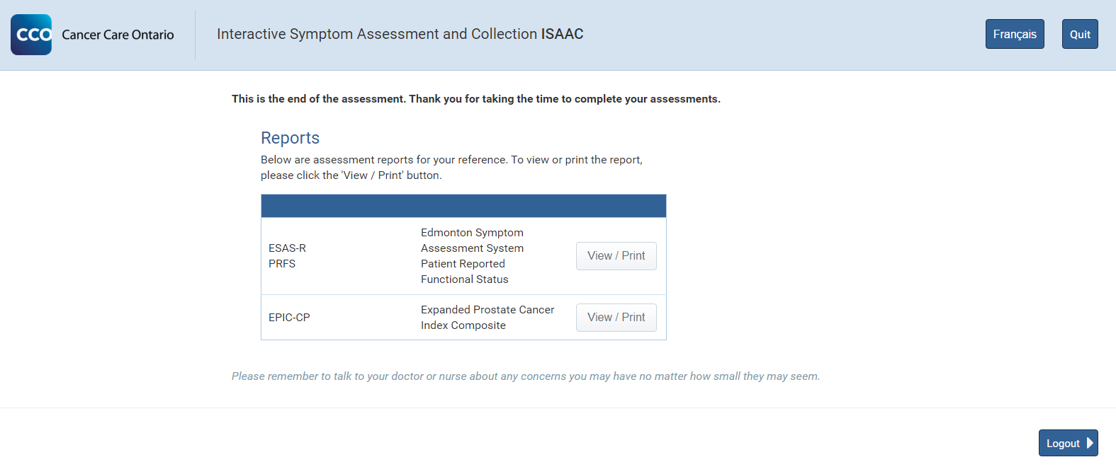

Reading the Report Contents
The End of Survey Report contains your symptom scores for up to 20 of your most recent surveys. The score is displayed as a histogram with the question to the left. The date and location of the completion of the survey displays above the histograms with a legend at the bottom of the page.
Figure 15: The End of Survey Reports for ESAS and PRFS
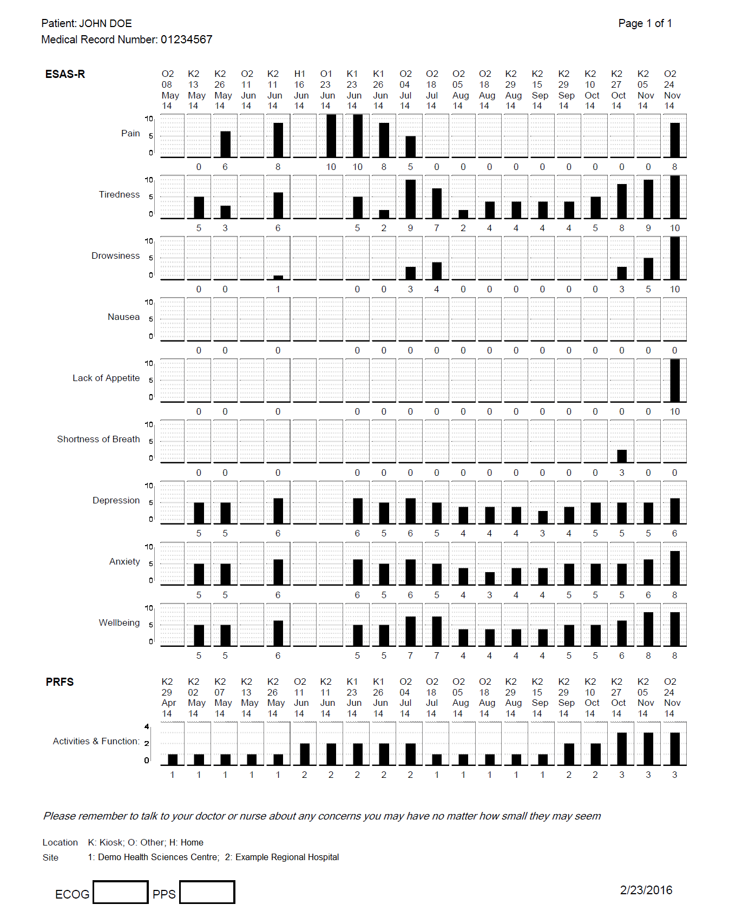

Supplementary Information

Overview
Supplementary Information is a document provided for the purpose of giving you more information about a health issue. This document is displayed to you based on your answer to a question. This document is provided to you after you complete the survey. However, if you have multiple surveys to complete, then this information is given to you only after all surveys are completed.

Kiosk
At the kiosk, the supplementary information is automatically printed after the completion of surveys. It cannot be viewed at the kiosk.

Home
From the internet browser, you can view and print the supplementary information from the same page as your End of Survey Reports.
Figure 16: Home Print Reports Page Including Magnified Supplementary Information
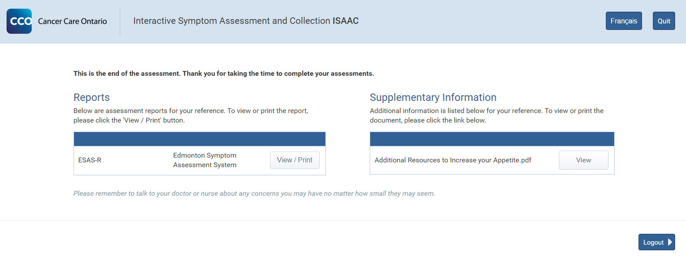
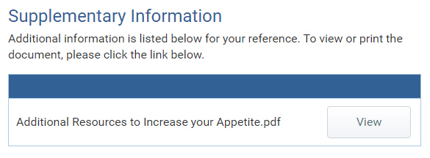

Logging Off and Quitting

Overview
This section shows you how to log off from the ISAAC application. At the kiosk, you are automatically logged off after the Supplementary Information and the End of Survey Report are printed.
From the internet browser, click on Logout to log out after viewing or printing the Supplementary Information and the End of Survey Report.
From the kiosk, the end of survey message will be shown once the patient has clicked Done and the reports have been sent to the printer.

Logout before Survey Completion
You can leave the ISAAC application from any page. However, if you leave the application during a survey or from the Review page, your survey responses are not saved. This means you will have to re-take the survey the next time you log in. A warning message is displayed when you try to quit during a survey or from the Review page.
Figure 17: The Quit Button Triggered Warning Message
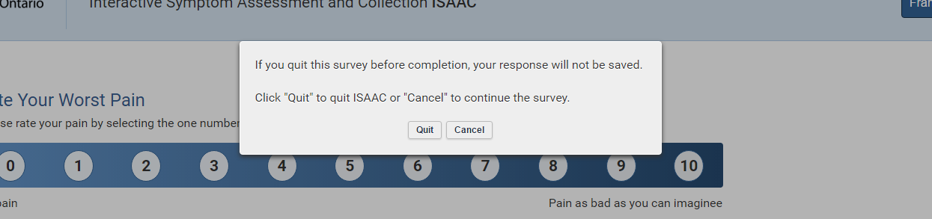
Please Note: At the kiosk, if you completed one survey and are quitting during the second survey then you may need to pick up the printouts for either or both supplementary information and End of Survey Report.

Automatic Logout for Idle Sessions
The ISAAC application has a built-in timeout feature. This feature will automatically logout patients that have been idle for a few minutes. This feature is to support patient privacy so that other people will not have access to your health information without your knowledge. This feature exists for all kiosks which have been deployed in the cancer centres and for your personal devices if you access ISAAC from your computer browser, phone or tablet.
If you are still using ISAAC, the application will give you a warning and allow you to continue without automatically logging you out of the session.

Helpdesk and Error Messages

Overview
Please contact your hospital’s ISAAC Administrator with any issues you may have, or consult the Errors and Warning Messages list below.

Error and Warning Messages
This chapter provides a list of all error and warning messages that may be displayed to you while you are logged into ISAAC.
Figure 18: Table of Errors and Warnings
Type | Description | Explanation
Login | Your login information is incorrect. Please try again. | This is the default CCO error message when a patient has entered incorrect HCN/MRN or they are not enrolled to use ISAAC.
Login | You have been discharged from ISAAC. Please contact your local support person for assistance. | This error occurs when a patient tried to login to a site they have been discharged from.
Login | Invalid card number. Please try again. | This error occurs when the card swipe reader could not read the Health Card Number.
General | An unexpected error occurred while processing your action. The error has been logged and a system administrator has been contacted. We apologize for any inconvenience. | This error is displayed when a fatal error occurred in the application.
General | Invalid kiosk. Please contact the site administrator to setup the kiosk. | This error occurs when the kiosk GUID provided in the user agent string can’t be verified.
General | Page not found. | This error occurs when the user attempts to navigate to a page that does not exist.
General | The requested resource could not be found. Please check the resource name or contact the site administrator | This error occurs when the user attempts to navigate to a page that does not exist.
Survey | You have no more surveys to take today. | This warning is displayed when the patient has completed all of their surveys for the day.
Survey | You have no surveys to take today. Please try again another day. | This warning is displayed when the patient has no surveys to take at all.

Appendix A: Version History

Document History
Revision | Type | Revision Date | Revised By | Revision Details
0.1 | Draft | May 08, 2012 | Farah Hafeez | Initial Draft
0.2 | Draft | May 30, 2012 | Farah Hafeez | Added Screenshots
0.3 | Draft | Jul 10, 2012 | Peter Drinkwater | Added feedback from CCO
0.4 | Draft | Sep 17,2012 | Peter Drinkwater | Added feedback from CCO
0.5 | Draft | Jan 2, 2013 | Maria Illek | Edits
1.0 | Final | Jan 14, 2013 | Maria Illek | Updated Screenshots
1.1 | Final | Jan 9, 2014 | Elise Poupard | Edits and Updated Screenshots
1.2 | Final | Oct 16, 2014 | Elise Poupard | Edits for ISAAC Release 2.9, including removal of patient password
1.3 | Final | Feb 23, 2016 | Daniel Blekkenhorst | Updated CCO Branding and Screenshots for ISAAC Web Refresh Project. Content was updated for content that was no longer current.

Appendix B: List of Figures
Below is the list of each screenshot contained in the document. For reference, you can use the page number to find the figure or if you are using an electronic version of the guide, you can link directly from the line item below.
Figure 1: The Kiosk Welcome Page 6
Figure 2: The Kiosk Login Page 6
Figure 3: Login Page Health Card Number to Medical Record Number Selection 7
Figure 4: Internet Search for the ISAAC Login Page 8
Figure 5: The ISAAC Home Login Page 8
Figure 6: The French Translation Button 9
Figure 7: The French Translation of the ESAS Instructions Page 10
Figure 8: The Terms of Use Page 11
Figure 9: The Site Selection Page 12
Figure 10: The Survey Instruction Page 13
Figure 11: The Survey Question Page 14
Figure 12: The Survey Review Page 15
Figure 13: The List of Currently Offered Surveys in ISAAC 16
Figure 14: Home Print Reports Page 17
Figure 15: The End of Survey Reports for ESAS and PRFS 18
Figure 16: Home Print Reports Page Including Magnified Supplementary Information 19
Figure 17: The Quit Button Triggered Warning Message 20
Figure 18: Table of Errors and Warnings 21

