INTERIM - RADIATION TREATMENT QUALITY-BASED PROCEDURES (RT-QBP) CLINICAL TRIAL REQUEST INTAKE AND ASSESSMENT FORM

Instructions
The purpose of this form is to assess whether the RT Clinical Trial can be publicly funded and the funding rate based on standard of care for a specific disease. The request will be reviewed by the Radiation Treatment Quality Based Program (RT-QBP) and other stakeholder groups, where appropriate.
Prior to completing the form, please ensure that the request is for a new clinical trial, and:
- Meets Ontario Health’s (Cancer Care Ontario) definition of a radiation treatment clinical trial: is an intervention to evaluate a treatment protocol (dose/fractionation, technique, etc.) that has undergone institutional (peer) review and received ethics approval at the institutional or provincial level. (Note: this form can be submitted prior to ethics approval).
- Exclude clinical trials where the primary intervention is not radiation treatment (ex. quality of life, imaging, chemotherapy etc.).
- Clinical trials will be tracked by Ontario Health (Cancer Care Ontario) through Databook reporting by their unique identifier NCT#.
- If your centre is hosting and/or leading the clinical trial that multiple centres are participating in, one intake form can be completed on behalf of all participating investigators in the province. It is the responsibility of the lead centre to coordinate the submission with participating centres.
- We ask that centres notify Ontario Health (Cancer Care Ontario) when a clinical trial has closed.

Complete Sections A, B, C of this form and submit to OH-CCO_rtclinicaltrials@ontariohealth.ca .
Section D is the assessment of the trial completed by Ontario Health (Cancer Care Ontario).
Please note: The responsibility for filling out this form rests with the Manager of Radiation Therapy, or delegate at the Regional Cancer Program (in discussion with the clinical trials department, Head of Radiation Oncology and Medical Physics department).

SECTION A: REQUESTOR INFORMATION
Date: Click here to enter a date.
Applicant Name & Title: Click here to enter text.
E-mail: Click here to enter text.
Phone Number: Click here to enter text.
Note: Applicant refers to principle or local investigator.
Alternative Contact Details on behalf of the Applicant - optional
Name & Title: Click here to enter text.
E-mail: Click here to enter text.
Phone Number: Click here to enter text.
Submitting Treatment Centre Choose an item.:
If Other, Please Specify: Click here to enter text.
Note: Ontario Health (Cancer Care Ontario) only requires one submission for each clinical trial from a provincial clinical trials investigator.

SECTION B: CLINICAL TRIAL INFORMATION
Clinical Trial Title: Click here to enter text.
Clinical Trial Abbreviation: Click here to enter text.
Examples: KAITLIN, AURA, CATHERINE
NCT Number: Click here to enter text.
Note: if there is no NCT number associated with the trial, please indicate another ID (e.g. OCT, EudraCT, etc.) or N/A if not yet available
Participating Facilities: Click here to enter text.
Web Link to Trial (if available): Click here to enter text.
Example: Clinicaltrials.gov
Treatment Intent: Choose an item.
Disease Site: Choose an item.
Sub-Disease Site: Choose an item.
If disease site is not listed or multiple disease sites are applicable, please specify: Click here to enter text.
Interventional Dose (Gy): Click here to enter text. Fractionation: Click here to enter text.
Comments: Click here to enter text.
Please identify the radiation treatment protocol that would be considered Standard of Care (SOC) for the majority of patients to be enrolled in this trial or for those patients not enrolling on this clinical trial. Click here to enter text.
Recruitment Status: Choose an item.
Anticipated Start Date (Month/Year), if not active: Click here to enter a date.
Trial Sponsor: Click here to enter text.
Funding Source(s): Click here to enter text.
Examples: Industry, Cooperative Group (NCIC, OCOG, other), local investigator-initiated trial
Optional - Additional Information on the Clinical Trial:
Click here to enter text.

SECTION C: APPLICANT’S SIGNATURE
The applicant named above has reviewed and approved the information in this form
Submitting Applicant’s Signature:
Date of Applicant’s Approval: Click here to enter a date.

Appendix A: INTERIM RT-QBP Clinical Trials Request Intake Assessment Process and Timelines
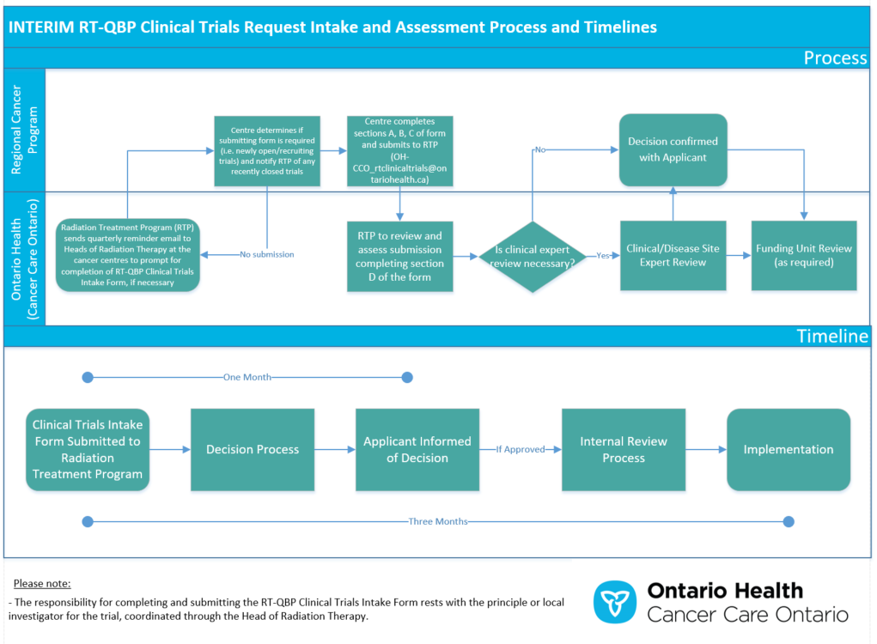

Appendix B: INTERIM Key Principle: Radiation Treatment Clinical Trials
Key Principle: Radiation Treatment Clinical Trials
Clinical Trials Definition for purposes of funding model work: A clinical trial is an intervention to evaluate a radiation treatment protocol which has undergone institutional (peer) review and received ethics approval at the institutional or provincial level.
Key Principle: The Ontario Health (Cancer Care Ontario) Radiation Treatment – Quality-Based Procedure (RT-QBP) will fund the standard of care, but will not fund anything incremental to the standard of care
Trial Phase and Funding Approach
Phase 3 or Randomized Phase 2: For trials with an evidence-informed standard of care arm, funding for all patients entered onto the trial will be provided at the level (band) of the standard of care
Phase 1 or 2:
For trials with a single arm study that adds or modifies a recognized evidence-informed standard of care, funding for all patients entered onto the trial will be provided at the level (band) of the standard of care
Funding for all patients entered onto a trial where there is no existing standard of care, the trial will be assessed and funded at the level(band) of the closest existing standard of care protocol from the RT-protocol list
The NCT number need to be reported as the RT Protocol (or other unique identifier)
- Funding cannot be triggered without the unique identifier (linked to standard of care)

SECTION D: INTERNAL USE: INTERIM NEW RADIATION TREATMENT(RT) CLINICAL TRIAL REQUEST ASSESSMENT FORM

COMPLETED BY ONTARIO HEALTH (CANCER CARE ONTARIO)
INSTRUCTIONS
The purpose of this form is to be completed by the Radiation Treatment Program, Ontario Health (Cancer Care Ontario) to evaluate RT-QBP Request Intake Form submissions received to OH-CCO_rtclinicaltrials@ontariohealth.ca .

FOR ONTARIO HEALTH (CANCER CARE ONTARIO) USE ONLY
Date Received: Click here to enter a date.
Clinical Trial Title: Click here to enter text.
Clinical Trial Abbreviation: Click here to enter text.
NCT #: Click here to enter text.
Participating Facilities: Click here to enter text.
Web Link to Trial (if available): Click here to enter text.
Disease Site: Choose an item.
If disease site is not listed or multiple disease sites are applicable, please specify: Click here to enter text.
Sub-Disease Site: Choose an item.
(If Applicable) Interventional Dose Range (Gy): Click here to enter text.
(If Applicable) Interventional Fraction Range: Click here to enter text.
Intent: Choose an item.
Recruitment Status: Choose an item.
Comment if Other: Click here to enter text.
Anticipated Start Date: Click here to enter a date.
Standard of Care Identification to One or Multiple Existing RT-Protocols:
Click here to enter text.
Describe rationale for the Standard of Care Protocol(s) Alignment (if applicable):
Click here to enter text.
Trial Sponsor: Click here to enter text.
Additional Information on the Clinical Trial: Click here to enter text.
Overall Assessment: Click here to enter text.
Evaluation: Choose an item.
Rationale: Click here to enter text.
RT-QBP Clinical Trial Reviewers Sign-Off: Click here to enter text.
Date Approved: Click here to enter a date.
FUNDING UNIT, ONTARIO HEALTH (CANCER CARE ONTARIO) INFORMATION:
Funding Rate: List the funding band for all standard of care protocols identified for mapping to the trial.
Additional Comments on Funding Band Information: Click here to enter text.
Funding Unit Sign-Off: Click here to enter text.
Date Approved: Click here to enter a date.

