NEW OR MODIFIED RADIATION TREATMENT (RT)-PROTOCOL INTAKE FORM

Instructions
The purpose of this form is to assess whether a new or modified RT-Protocol for a specific disease site can be publicly funded and assess the funding rate. The request will be reviewed by the Radiation Treatment Program and Funding Unit, and other groups, where appropriate at Cancer Care Ontario (Ontario Health).
Prior to completing the form, please ensure the following:
- This request is for a new or modified RT-Protocol:
  - A net new RT-Protocol refers to a protocol that has not previously been reviewed and is not listed on the current Ontario Health (Cancer Care Ontario) Data Book (Appendix 1.46 Radiation Treatment (RT)-Protocol).
  - A modified RT-Protocol refers to a protocol that exists on the current Ontario Health (Cancer Care Ontario) Databook (Appendix 1.46 Radiation Treatment (RT)-Protocol) but requires modification to substitute an existing protocol.
- Submission process has been reviewed (Appendix 1)
- Submission is for one new or modified RT-protocol
Submission instructions:
Submitting centre to complete Sections A and B of this form and submit by email to OH-CCO_RadiationQBP@ontariohealth.ca
- Any applicable supporting documentation (i.e. publications) may be submitted by email along with this completed form.
- Sections A and B are required sections and must be completed by the Manager of Radiation Therapy, or delegate (in discussion with the Head of Radiation Oncology and Medical Physics)
Please Note: The responsibility for filling out this form rests with the Manager of Radiation Therapy, or delegate, at the Regional Cancer Program and should be coordinated through the Regional Directors office

SECTION A: SUBMITTING CENTRE INFORMATION
Note: One submission per one new/modified RT-protocol required
Date: | Click here to enter a date.
Manager of Radiation Therapy Name: | Click or tap here to enter text.
E-mail: | Click here to enter text.
Phone Number: | Click here to enter text.
Submitting Treatment Centre: | Choose an item.
Delegate Contact Details on behalf of the Head of Radiation Therapy – as required
Name & Title: | Click here to enter text.
E-mail: | Click here to enter text.
Phone Number: | Click here to enter text.

SECTION B: RT-PROTOCOL INFORMATION
Intent of Submission:  Are you submitting a net new protocol or modifying an existing protocol? | Choose an item. |  |  |  | Comments Click here to enter text.
Protocol Name: | Click here to enter text.
Disease Site (Clinical Practice Group): | Choose an item. |  |  |  | If disease site is not listed please specify:  Click here to enter text.
Sub-Disease Site (Clinical Practice Subgroup): | Choose an item.
Body Region(s) Treated:  Use ALR codes for describing  If multi-phase please provide for Phase 1,2 etc. | Region(s)  Additional Region(s) |  | Region Groups(s) |  |  | Description
Modality: (Treatment Technique) | Choose an item. |  |  | Additional Modalities:  Click or tap here to enter text.
Treatment Intent: | Choose an item.
RT-Protocol Description: | Click here to enter text.
Dose Range: (Gy) (per phase as applicable): | Click here to enter text.
Fraction Range: (per phase as applicable): | Click here to enter text.
Boost Dose (Gy) and Fractionation Range (per phase as applicable): | Click here to enter text.
Dose per Fraction | Click or tap here to enter text.
Single or Multi-Phase Treatment: | Choose an item. |  |  | Comments:Click or tap here to enter text.
Quality Expectations:  Please identify possible quality expectations relevant to this treatment protocol, if not already identified for this disease site in the RT-QBP Quality Expectations Document:  Example: Tangent beams should be delineated to minimize the dose to the heart (ALARA) | Click here to enter text.
Describe Level of Clinical Evidence
Ex. Clinical trial level 2, publication/guideline document, protocol with a significant course count in the province, protocol has a significantly higher cost than current standard of care and should be considered separate etc.
Describe the Level of Clinical Evidence or change in practice required that supports the new/modified RT-protocol. Provide detail in the following sub-categories as applicable: | Clinical evidence:  Click here to enter text. | Guideline/Publication: Click here to enter text. |  |  | Data Supporting Regular Use in Province:  Click here to enter text. |  | Cost Factors:  Click here to enter text.
Introduction of new technology (ex. Imaging technique/planning criteria/capital equipment)
Click here to enter text.
Rationale for New or Modified RT-Protocol: | Click here to enter text.
Additional Detail on the Level of Clinical Evidence: Ex. Publication Title etc. | Click here to enter text.
Anticipated Start Date (DD/MM/YYYY): | Click here to enter a date.
Estimated Volume/Year at your Centre  (if available): | Click here to enter text.
Additional Comments: | Click here to enter text.
For additional information related to this work, please feel free to contact the Radiation Treatment Program at OH-CCO_RadiationQBP@ontariohealth.ca

APPENDIX 1: New RT-Protocol Process and Timeline
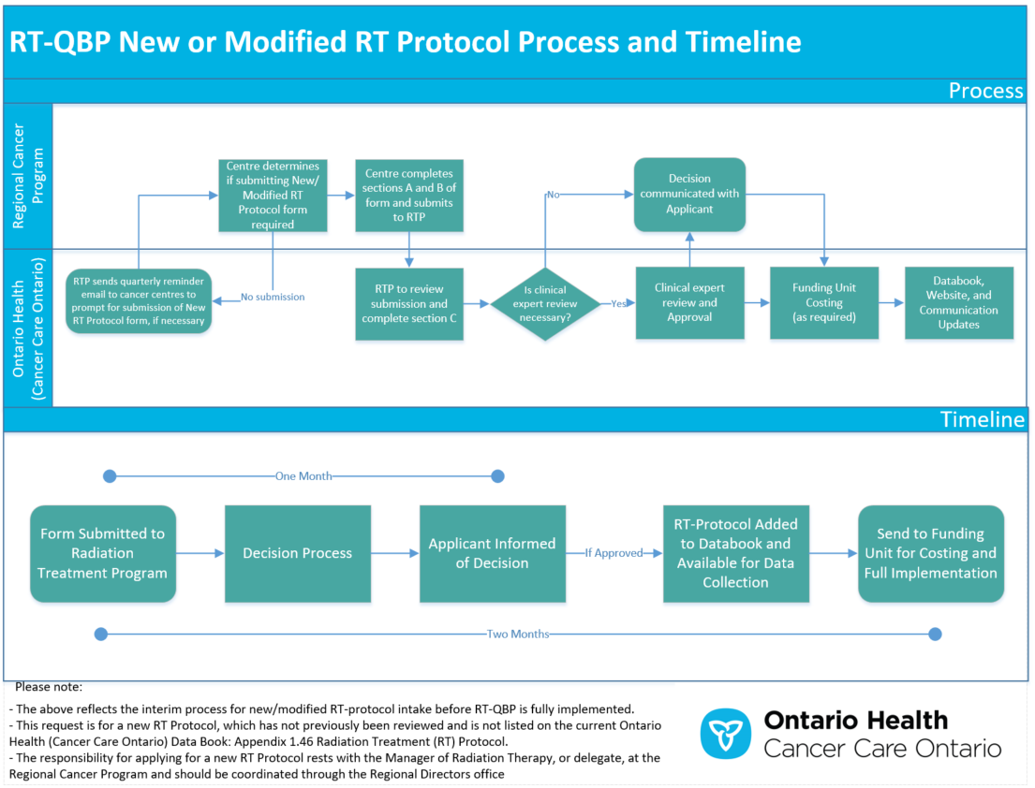
SECTION C: ASSESSMENT OF NEW OR MODIFIED RADIATION TREATMENT(RT)-PROTOCOL SUBMISSION
COMPLETED BY ONTARIO HEALTH (CANCER CARE ONTARIO)
SECTION C: ASSESSMENT OF RT PROTOCOL FOR RADITION TREATMENT PROGRAM, ONTARIO HEALTH (CCO) USE ONLY
Date Received: | Click here to enter a date.
Eligibility Criteria
Does Submission Require Clinical Expert Review Beyond RTP/Provincial Head, RT (CCO)
Date of Assessment | Click here to enter a date.
Fiscal Year | Choose an item.
Criteria for Clinical Expert Panel Review | Substantial Change in Practice: Choose an item. |  |  |  |  |  |  |  | Comments/Other: Click here to enter text.
Evaluation of Level of Clinical Evidence: | Clinical evidence:  Click here to enter text. |  | Guideline/Publication: Click here to enter text. |  |  | Data Supporting Regular Use in Province:  Click here to enter text. |  |  | Cost Factors:  Click here to enter text.
Introduction of new technology (ex. Imaging technique/planning criteria/capital equipment)
Click here to enter text.
Rationale for the New or Modified RT-Protocol | Click here to enter text.
Additional Comments on Level of Clinical Evidence: | Click here to enter text.
Benefits of the RT Protocol
There is an unmet clinical need: | Yes ☐ | No ☐ |  | N/A ☐ |  |  | Comments Click here to enter text.
There is clinically meaningful benefit: | Yes ☐ | No ☐ |  | N/A ☐ |  |  | Comments Click here to enter text.
The protocol will improve a patient’s quality of life (less toxicity, reduced disease-related symptoms) or not cause a significant decrement in quality of life: | Yes ☐ | No ☐ |  | N/A ☐ |  |  | Comments Click here to enter text.
The new protocol will reduce health system pressures and is otherwise clinically equivalent (effectiveness, safety)
The new protocol will increase the efficiency or reduce workload of the cancer treatment facility: | Yes ☐ | No ☐ |  | N/A ☐ |  |  | Comments Click here to enter text.
The new protocol is less costly than the comparator it could replace: | Yes ☐ | No ☐ |  | N/A ☐ |  |  | Comments Click here to enter text.
The new protocol provides patients with an option when the standard treatment cannot be used: | Yes ☐ | No ☐ |  | N/A ☐ |  |  | Comments Click here to enter text.
Overall Assessment of Level of Clinical Evidence: | Click here to enter text.
Comments for Funding Team: | Click here to enter text.
New RT Protocol Name: | RT_PROTOCOL_CD |  |  |  | RT_PROTOCOL_DESC |  |  | RT_PROTOCOL_SHORT_CD
 | Click or tap here to enter text. |  |  |  | Click or tap here to enter text. |  |  | Click or tap here to enter text.
Indications (Optional) | Click or tap here to enter text.
Submission Assessment Result: | Choose an item. | If other, please specify |  | Click here to enter text.
RT-QBP Reviewers Sign-Off:  (Ex. RTP team/CQLs/Clinical Disease Site Experts etc.) | Click here to enter text. |  |  |  |  |  |  |  | Comments: Click here to enter text.
Date Approved: | Click here to enter a date.

