**Image Guided Radiation Therapy for Head and Neck Cancer**

**Recommendation Report**

A report developed by the Head and Neck Community of Practice of the Radiation Treatment Program of Cancer Care Ontario for circulation to Regional Cancer Programs

Report Date: February 2017

Table of Contents

GLOSSARY 3

1. INTRODUCTION 4

2. RECOMMENDATIONS 5

3. PREAMBLE 6

4. METHODS 7

5. RESULTS 8

5.1 IGRT Infrastructure 8

5.2 HN IGRT Protocol Considerations 8

5.2.1 Immobilization 8

5.2.2 IGRT Workflow 8

5.2.3 Establishing action levels 12

5.2.4 Imaging frequency, action levels and correction protocol 12

5.2.5 Imaging volume of interest and global registration 12

5.2.6 Local and priority matching assessment 15

5.2.7 Evaluation of external contour change 15

6. CONCLUSIONS 17

CONTACT INFORMATION 18

ACKNOWLEDGEMENTS 18

DISCLAIMER 19

COPYRIGHT 19

REFERENCES 20

APPENDIX 23

# GLOSSARY

**2D imaging**: Megavoltage portal image (MV) or kilovoltage x-ray image (kv) projections / radiographs in principle planes

**3D imaging**: including all volumetric kv-CBCT (cone beam computed tomography), Megavoltage computed tomography (MVCT)

**Volume of Interest (VOI)**: pertains to clip box / scan volume in 3D-imaging, intersection of orthogonal 2-D portal images

**On-line matching protocol**: shifts performed with patient on treatment couch, accounts for random and systematic error

**Off-line matching protocol**: shifts determined with patient off treatment couch for a number of X fractions (fx), systematic error determined and incorporated into daily set-up protocol

**Residual error**: spatial misalignment discrepancies relative to planning CT post shift uncertainty due to uncertainty in image registration, mechanical accuracy, patient deformation unaccounted for my the image guidance process and intrafraction motion during imaging and treatment

**Action level:** The maximum permitted difference between the measured and its associated reference value that, if exceeded, requires an immediate response to return the system back to a state within the normal functioning range.

# INTRODUCTION

**Goals**

The goals of the report generated by the Head and Neck (HN) Community of Practice (CoP) Image Guided Radiation Therapy (IGRT) Working Group of the Radiation Treatment Program (RTP) of Cancer Care Ontario (CCO) were to:

* Assess the current state of HN IGRT practice across all HN cancer centres in Ontario
* Set best practice recommendations for HN IGRT processes
* Develop IGRT recommendations and standardized nomenclature for HN image matching

This initiative was undertaken by the HN IGRT Working Group for the following reasons:

* To verify, based on existing literature, of current HN IGRT protocols and provide a better understanding of these processes
* To identify areas of weakness / ambiguity in current HN IGRT practice and provide recommendations for future areas of development
* To standardize quality of care across the province for HN IGRT
* To create a common terminology and language for HN IGRT
* To facilitate standardized data collection for province wide comparison of HN IGRT protocols
* To facilitate local HN IGRT training and credentialing

**Scope**

The following technologies/techniques were included in the scope of the HN IGRT Working Group:

* All 3D-3D including kv-CBCT, MVCT, MV-CBCT
* All radical IMRT/VMAT treatments (> 20 Fx)

The following technologies/techniques were excluded from the scope of the HN IGRT Working Group:

* Cyberknife

# RECOMMENDATIONS

**It is the recommendation of the Ontario Radiation Treatment HN CoP IGRT Working Group that all HN patients should receive daily pre-treatment imaging to ensure that the intended dose is accurately delivered to the correct spatial location.** In the case of laryngeal disease, where soft tissue matching is essential, volumetric 3D imaging is required due to the inability of 2D imaging techniques to adequately visualize soft tissue. Furthermore, it is recommended that for comprehensive HN image verification, 3D volumetric imaging be the primary IGRT modality of choice. We note that when resources are limited, daily 2D orthogonal kV imaging can be used for non-laryngeal sites although it is recommended that 2D imaging be supplemented with 3D volumetric imaging for assessment of external soft tissue changes that are expected to occur during the radiotherapy course.

Given these recommendations, this report discusses the main considerations in HN IGRT protocol with regards to 3D imaging including KV and MV CBCT, CT on rails and Tomotherapy MVCT.

Although many of the recommendations will also apply, 2D imaging matching will not be discussed.

Key IGRT workflow steps are included and provide a framework that is flexible enough to consider individual clinic needs while ensuring a minimum standard of care.

# PREAMBLE

In the modern era, HN cancer patients are typically treated with Intensity Modulated Radiation Therapy (IMRT) or Volumetric Modulated Arc Therapy (VMAT) that generates sharp dose gradients that require precise spatially accurate delivery to ensure target coverage and minimize toxicity to surrounding organs at risk (1).

A planning target volume (PTV) margin is employed around the clinical target volume (CTV) to account for uncertainties in patient set-up (2-4). However, during the course of a 6-7 week daily fractionated schedule, additional factors such as patient weight loss, tumor shrinkage, or amendments to patient immobilization devices due to acute organ reactions, may influence patient shape and posture leading to deformations and compromising the patient treatment plan both dosimetrically (5-7) and spatially (8-11). Geometric treatment verification is important for detecting potential treatment delivery errors and ensuring the adequacy of the chosen PTV margins. Further, daily image guidance provides the potential for reducing PTV margins and reducing patient toxicity (12-14). In the absence of daily imaging, PTV margins may need to be increased.

IGRT utilizes daily 2D or 3D images that are registered with planning CTs to shift the treatment couch such that the target volumes and organs at risk (OARs) are accurately aligned with their intended treatment positions. Both 2D and 3D modalities provide similar global corrections in the head and neck region when boney matching is employed. However,2D (planar) imaging has been shown to be limited in assessing rotations and deformations compared to 3D (volumetric) imaging and provides limited soft tissue visualization (15-18)*.* 3D imaging allows for changes in soft tissue to be visualized for adaptive re-planning or off-line dosimetric assessment (19-21).

A recent survey by the HN IGRT Working Group showed that 3D imaging is the most commonly adopted form of IGRT for head and neck external beam radiation therapy. However, inconsistencies in IGRT practice were identified indicating the need for a consensus document based on evidence-based guidelines. This document provides evidence based guidelines for setting up an appropriate management infrastructure, workflow and protocols for a cancer centre implementing daily on-line 3D imaging for HN patients. The Appendix summarizes HN IGRT practices across all centres treating radical HN patients compiled via: provincial survey and collation of all CCO HN IGRT protocols.

# METHODS

This report was developed by the IGRT Working Group, which was established by the CCOHN CoP. Peer-reviewed literature, current clinical practice, centre-specific protocols, and survey results of a current state assessment of IGRT practice in Ontario were considered during the development process. For additional details regarding the literature and protocol review as well as the current state assessment survey, please contact the CCO RTP ([RTP@cancercare.on.ca](mailto:RTP@cancercare.on.ca)).

# RESULTS

## IGRT Infrastructure

The following recommendations are based on the assumption of an already existing IGRT program with fully commissioned equipment and validated imaging protocols. Quality assurance (QA) protocols should be in place to assess image quality as well as verifying the accuracy of the imaging system, matching software, coordinate system and couch shifts with end-to-end tests. The QA program should be developed with the local medical physicist(s) and depending on the utilized imaging modality follow the minimum standards of reported recommendation documents (Royal College of Radiologists, CPQR, AAPM TG-104, TG-148**,** TG-179) (22-25). A multi-disciplinary IGRT team should already be established that will define protocols and procedures and standardize training and authorization for each site group. The following sections focus on the implementation of ***head and neck*** specific IGRT protocols and outlines key considerations.

## HN IGRT Protocol Considerations

### 5.2.1 Immobilization

Geometric accuracy and corresponding PTV margins will depend on the local immobilization technique (22). Patient immobilization should be performed in the supine position using a thermoplastic mask (3 point, 4 point or 5 point fixation) covering the head and neck. Immobilization of the shoulder region is strongly suggested either by an extended mask to the shoulders or supplementary fixation devices (e.g., bear claw, straps etc.). In addition, mask cut outs to reduce acute skin reactions can be employed without significantly impacting set-up accuracy (26-27).

### 5.2.2 IGRT Workflow

All HN IGRT should follow a standard protocol that defines a clear decision workflow specifying actions to be taken throughout the IGRT process. These protocols should be developed using a multi-disciplinary approach and should consider local resources (equipment, software, personnel) and clinical context. Responsibilities should be clearly defined and assigned for each task in the decision tree. Specifically, image approval should be performed by staff who are fully trained to the local matching standards and policies of the institution. It is also recommended that an independent check be performed during treatment or off-line to verify matching consistency. A recommended framework for HN image-guidance is shown in Figures 1 and 2 for standard HN and early glottis patients, respectively.

The workflow also indicates specific steps that can be adjusted depending on local resources. As shown in Figure 1 and 2, patients exceeding global set-up tolerances (Section 5.2.7) are re-positioned and re-imaged up to a nominal number of times depending on local protocol. In the event that set-up error persists, CT simulation staff, physicists and radiation oncologists may be contacted in resolving set-up issues. Set-ups deemed appropriate to proceed are documented in the electronic system of record and reviewed again off-line by both radiation oncologists and physicists to assess clinical impact. Unresolvable discrepancies may result in new plans. In such cases, it is important to consider the biological consequence of treatment breaks and the cost-benefit of remaining treatment fractions.

The primary components of the workflow include:

1. Definition of a volume of interest (VOI)
2. Local set-up error assessment
3. Soft tissue assessment
4. Determination of action levels

Specific recommendations are provided for all components are provided in Sections 5.2.3-5.2.7.

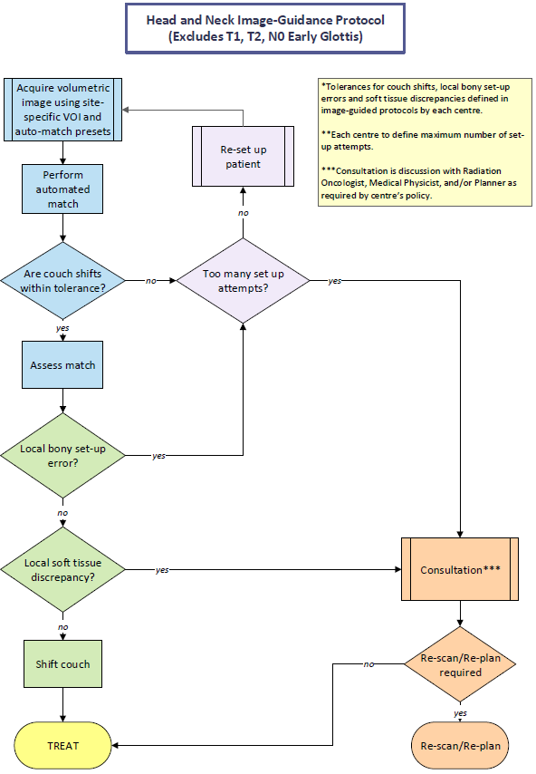

**Figure 1:** *Suggested HN IGRT workflow (excl. early glottis)*

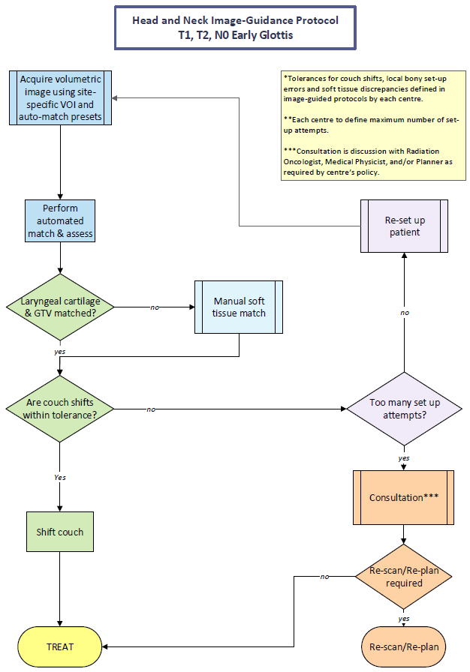

**Figure 2:** *Suggested HN IGRT workflow for early glottis*

### 5.2.3 Establishing action levels

Action levels defined for IGRT should consider the PTV margins employed at each centre. Within Ontario, most centres employ daily imaging with a 5 mm PTV margin for HN IMRT/VMAT treatment modalities although smaller margins have been reported. The PTV margins and corresponding set-up tolerances should be determined from a 3D imaging study to assess systematic and random errors in Cartesian directions over a population average using the same immobilization and IGRT protocol used for treatment (22,30). A sample of size of at least 20 patients and 5 images is recommended to reduce uncertainty in the systematic error. Several margin recipes exist (4, 31-33) and are generally based on the framework of van Herk et al (33): $Margin= 2.5+0.7$ where and are the quadratic sum of the standard deviation of all systematic and random errors. The determined margin will allow the CTV, for 90% of all patients, to be covered with the 95% isodose line* (33).

### 5.2.4 Imaging frequency, action levels and correction protocol

Geometric tolerances define the permitted range of set-up errors that is therapeutically acceptable for patient care and are typically defined by the PTV margin. Set-up errors are defined relative to a correction point – typically the treatment isocenter or center of the registration VOI. Translational action levels provide a warning for gross errors due to set-up errors or deformations in patient anatomy. The PTV derived action levels will be incorporated into the IGRT workflow (Section 5.2.2) to set criteria for adjusting patient set-up, repeat imaging or initiating consultation with the IGRT team for deciding the course of treatment.

A centre specific imaging frequency and correction protocol should be determined for each locally employed PTV margin. The HN IGRT CoP **recommends that all centres employ a daily, on-line IGRT correction protocol for HN patients.** This protocol leads to a much smaller residual uncertainty by reducing both systematic and random geometric errors (22, 34) and has been implemented in the majority of Ontario centres. It is vital that resource implications are considered early in the implementation process such that added workload is managed appropriately. An additional challenge for implementing a daily, on-line IGRT program is a concern for physicians due to added imaging dose. Discussions with local physicians should stress the improved quality of care for HN patients. Specific examples include the reduction of gross errors (35-36) as well as the potential of reduced PTV margins and corresponding reduced normal tissue complications (12-14). In addition, while much smaller than the therapeutic dose, AAPM TG-75 (37) has compiled a comprehensive summary of radiation dose levels for common image-guidance techniques. The document also provides strategies for reducing imaging dose while maintaining image quality and rigorously discusses the trade-off of added imaging dose relative to improvements in therapeutic dose delivery.

### 

### 5.2.5 Imaging volume of interest and global registration

Following 3D IGRT imaging, registration is performed with the planning CT image to assess patient set-up and determine couch shift corrections. A pre-defined registration protocol should be in place to ensure consistent and accurate set-up corrections (38-39). To avoid user inconsistencies, global matching should be performed using a standard volume of interest (VOI) utilizing an automatic matching algorithm followed by an assessment of the registration quality. Poor registrations may require additional adjustment of the VOI. Manual registration changes may also be performed although at the risk of increased user variation. Irresolvable registration issues should be discussed with a consulting physicist and radiation oncologist.

Boney surrogates to the PTV may vary and should be identified in protocol or standardized templates. Figure 3 provides a list of recommended boney and soft tissue surrogates for local assessment of common HN sub-site volumes and their respective target and OARs. If possible, physician created or automatically segmented matching contours can be exported to the IGRT software to aid in registration. While shoulders are generally not included in the global registration volume, dosimetrically they are of concern with regards to beam clipping, particularly for target volumes that extend into the supraclavicular region, and should be included in the evaluation process.Regardless of the protocol defined matching surrogates (i.e. boney, soft tissue), the matching volume should focus on the high dose CTV region.

Head and neck specific 3D imaging systems and image quality should be evaluated for local needs by medical physics with feedback from both radiation therapy and oncology prior to IGRT implementation. The imaging protocol should consider an adequate field of view (FOV) that will cover the target and OARs with image contrast and resolution balanced against patient imaging dose and total imaging time.

In Section 5.2.5a-b, recommendations are provided for a standardized VOI.

#### 5.2.5.a Standard HN VOI (excl. early glottis)

A standard VOI for each HN sub-site should be placed around bony surrogates surrounding the PTV. Figure 3 lists recommended boney OAR and target surrogates for a range of HN sub-sites. At minimum, it is recommended that in all planes, the VOI cover the high dose PTV by at least 1-2 cm. We note that while neck node volumes may extend as far inferiorly as C7, elongated VOIs often cause problems for global automatic matching algorithms. Elongated low dose PTV volumes may be excluded from the standard VOI but should be assessed for bony set-up errors.

#### 5.2.5.b Early glottis VOI

Recent literature (40) has shown poor correlation of local boney surrogates with soft tissue of the glottic region. For small field larynx treatments, the VOI should focus on the high dose PTV soft tissue anatomy with a corresponding grey scale match. Ensure that the superior border is inferior to the hyoid bone and the inferior border is 1 cm inferior to the cricoid cartilage*.* The anterior border should cover the thyroid cartilage.

|  |  |  |
| --- | --- | --- |
| **Volume-of-interest Box** | | **Matching Structures** |
|  | **Nasal Cavity** |  |
|  |  | * high-dose CTV * frontal & spenoid sinuses * nasal cavity * clivus * orbits * C1/C2 * brainstem |
|  | **Nasopharynx** |  |
|  |  | * high-dose CTV * clivus * sphenoid sinus * Brainstem * C1-C4 |
|  | **Oropharynx** |  |
|  |  | * high-dose CTV * vertebrae at level of highest cord dose |
|  | **Oral cavity** |  |
|  |  | * high-dose CTV * mandible * vertebrae at level of highest cord dose |
|  | **Early glottis (T1N0, T2N0)** |  |
|  |  | * high-dose CTV * thyroid & cricoid cartilage * glottis   **Exclude hyoid bone and vertebral bodies |

**Figure 3.** Key matching structures to include in the global registration VOIbox for various head and neck cancer sites. Images on the left-hand side show the relevant VOI box (red) on the sagittal, coronal, and axial views.

### 

### 5.2.6 Local and priority matching assessment

Following global registration, rotational corrections are typically zeroed (i.e. ignored or incorporated into the translation shifts resulting in slight differences from the original match). , Assessment is required to determine if set-up errors from local sub-volumes exceed the global set-up uncertainties derived from the larger VOI. At this stage, additional adjustments (i.e. clip box changes, manual) may be necessary to optimize the local match of the high dose PTV and surrounding OARs based on matching priority (40-43). Matching structures that aid in outlining and visualization for optimal IGRT matching should be exported to the treatment console with specific areas of dosimetric interest noted by the treating physician, physicist or dosimetrist to aid in daily image matching. Structures should be prioritized regarding matching importance in a step-wise, sequential fashion. OARs close to dose tolerance may be designated with exact matching priority while lower priority structures may be assigned tolerances up to the corresponding planning PTV or PRV margins. For non-standard cases, the radiation oncologist should clearly highlight patient specific structures of interest (including boney surrogates) and adjusted correction tolerances that the treatment unit should be aware of during IGRT. These instructions should follow a standard template and be documented in the local electronic medical record (EMR). Figure A1 summarizes the IGRT guidelines of all Ontario cancer centres that treat HN cancer with radiation therapy and shows significant variability in the instructional content for performing IGRT.

For early glottis patients, the working group recommends a priority match assessment as follows:

1. Soft tissue of the glottis, thyroid and cricoid cartilage (to be encompassed by VOI)

Vertebral bodies can be used to assess overall accuracy of set-up.

For all other head and neck sites, the IGRT Working Group recommends a priority match assessment as follows:

1. Spinal cord at level of highest dose (vertebrae to be included in VOI)
2. Boney surrogates adjacent to high dose PTV (to be identified and standardized by department protocol, included in VOI )
3. Low dose PTV volumes outside of VOI for local boney set-up errors. Assess outside of clip box for low dose PTV coverage
4. Shoulders to ensure no beam clipping (see Figure A2 in Appendix)
5. Soft tissue changes (i.e. weight loss, tumor growth) on high and low dose PTV coverage

Note that the matching priorities stated above are general and may be superseded by patient specific structures specified by the physician. Regardless, each priority match should satisfy a pre-defined set-up error tolerance.

### 5.2.7 Evaluation of external contour change

Over the course of a 4-6 week HN radiation treatment patient will often lose weight. This weight loss will manifest as gaps under the immobilization mask and / or patient set-up issues. In such cases, global translational tolerances may be exceeded near the end of a patient treatment that may require a re-plan. Alternatively, set-up may remain stable while dosimetric consequences may arise from a loss of tissue (19,21). Local tolerances based on patient anatomical changes should be established using 3D IGRT imaging that initiate a dosimetric investigation by physics and dosimetry with the results of such investigations reported to the treating radiation oncologist (see Section 5.2.2). In either case, guidelines should be determined that consider the remaining number of fractions that optimize planning workload and dosimetric accuracy. Table A2 summarizes the current considerations employed by Ontario cancer centres for initiating an adaptive re-plan.

# CONCLUSIONS

IGRT for the HN region is a complicated multi-step process that covers the entire radiation therapy process from simulations to on-line image verification at the treatment unit. Image guidance protocols should be developed with multiple disciplines including therapy, physics and oncology. It is hoped that the recommendation report will help standardize the practice of HN IGRT across Ontario and provide a blue-print for centres new to adopting 3D imaging at their centre.

# CONTACT INFORMATION

It is CCO’s intention to disseminate this report to the Regional Cancer Programs and advisory committees within the province and to make the document available to the Ontario healthcare providers on the CCO website ([www.cancercare.on.ca](http://www.cancercare.on.ca)). This report will be reviewed on a regular basis to determine whether the information is still accurate and relevant to current practice and revised accordingly.

For general inquiries regarding this report, please contact: [Eric.Gutierrez@cancercare.on.ca](mailto:Eric.Gutierrez@cancercare.on.ca) or [RTP@cancercare.on.ca](mailto:RTP@cancercare.on.ca)

# ACKNOWLEDGEMENTS

This recommendation report was developed by a special working group of the Radiation Treatment Program’s Head and Neck Community of Practice. Members of the *IGRT for HN Working Group* include: Lee Chin (lead), Wendy Schoen (lead), BA, MRT(T); Kim Dalley, MRT(T), DCR(T); Suzanne Gillespie, MRT(T), RTT, ACT, BSc, CTIC; Danielle Morin, MRT(T), BSc (Hons.); Natassia Naccarato, MRT(T), BSc; Jennifer Stones, MRT(T), BSc; Ryan Studinski, PhD, MCCPM; Khaled Zaza, MD FRCPC.

This report was developed with the assistance of the Head and Neck Community of Practice Leadership Group: Stephen Breen, PhD, MCCPM; John Kim, MD, FRCPC; Dani Scott, MRT(T); Khaled Zaza, MD, FRCPC and the Radiation Treatment Program: Elizabeth Lockhart, MSc; Eric Gutierrez, MRT(T), CMD, BSc; Padraig Warde, MB, MRCPI, FRCPC.

# 

# DISCLAIMER

* This recommendation report was developed by a working group of the HN CoP of the RTP of Cancer Care Ontario. The working group was comprised of head and neck radiation treatment professionals belonging to the disciplines of radiation oncology, medical physics, and radiation therapy. The material presented in this recommendation report illustrates the consensus reached among members of the HN CoP and may not reflect current practice at all Ontario cancer centres. All approaches to treatment are subject to clinical judgment and actual practice patterns may not follow the material outlined in this report.
* This recommendation report may not reflect all the available scientific research and is not intended as an exhaustive report. CCO and HN CoP members assume no responsibility for omissions or incomplete analysis resulting from this recommendation report. It is possible that other relevant scientific findings may have been reported since completion of this recommendation report. This recommendation report may be superseded by an updated publication on the same topic.
* This recommendation report is not a clinical guideline or practice standard, and was *not* developed in collaboration with CCO’s Program in Evidence-Based Care (PEBC). Evidence-based guidelines for head and neck cancer are available through the [PEBC.](https://www.cancercare.on.ca/cms/one.aspx?portalId=1377&pageId=7582)
* This recommendation report is intended to be used for informational purposes only, by radiation treatment professionals. It is not intended to constitute or be a substitute for medical advice and should not be relied upon in any such regard. Any person seeking to apply this recommendation report is expected to use independent medical judgment in the context of individual clinical circumstances or seek out the supervision of a qualified clinician. CCO and HN CoP members make no representation or guarantee of any kind whatsoever regarding the content, use, or application of this recommendation report and disclaim any responsibility for its application or use in any way.

# COPYRIGHT

* This recommendation report is copyrighted by Cancer Care Ontario and may not be reproduced without the express written permission of Cancer Care Ontario. Cancer Care Ontario reserves the right at any time, and at its sole discretion, to change or revoke this authorization.

# 

# REFERENCES

1. Corvo R. Evidence-based radiation oncology in head and neck squamous cell carcinoma. Radiother Oncol 2007 85: 156-70
2. ICRU Report 50, Prescribing, Recording, and Reporting Photon Beam Therapy, ICRU News 1993. http:// www.icru.org/pubs.html
3. Wambersie A, Landberg T. ICRU Report 62: Prescribing, Recording and Reporting Photon Beam Therapy (Supplement to ICRU Report 50). ICRU News 1999. <http://www.icru.org/n_992_4.ht>ml
4. van Herk M, Remeijer P, Lebesque JV. Inclusion of geometric uncertainties in treatment plan evaluation. Int J Radiat Oncol Biol Phys 2002;52(5):1407-22
5. Wu Q, Chi Y, Chen PY, Krauss DJ, Yan D, Martinez A Adaptive replanning strategies accounting for shrinkage in head and neck IMRT. Int J Radiat Oncol Biol Phys. 2009 Nov 1;75(3):924-32. doi:10.1016/j.ijrobp.2009.04.047
6. Bhide SA, Davies M, Burke K, McNair HA, Hansen V, Barbachano Y, El-Hariry IA,

Newbold K, Harrington KJ, Nutting CM. Weekly volume and dosimetric changes during chemoradiotherapy with intensity-modulated radiation therapy for head and neck cancer: a prospective observational study Int J Radiat Oncol Biol Phys. 2010 Apr;76(5):1360-8. doi:10.1016/j.ijrobp.2009.04.00

1. Yang H(1), Hu W, Wang W, Chen P, Ding W, Luo W. Replanning during intensity modulated radiation therapy improved quality of life in patients with nasopharyngeal carcinoma Int J Radiat Oncol Biol Phys. 2013 Jan 1;85(1):e47-54. doi: 10.1016/j.ijrobp.2012.09.033. Epub 2012 Nov 1.
2. Polat B, Wilbert J, Baier K, Flentje M, Guckenberger M. Nonrigid patient setup errors in the head-and-neck region. Strahlenther Onkol 2007;183:506–11.
3. Wang, J., Bai, S., Chen, N., et al. *The clinical feasibility and effect of online cone beam computed tomography-guided intensity-modulated radiotherapy for nasopharyngeal cancer.* Radiat Oncol, 2009. 90: p. 221–7.
4. van Kranen, S., van Beek, S., Rasch, C., van Herk, M., Sonke. J.J. *Setup uncertainties of anatomical sub-regions in head-and-neck cancer patients after offline CBCT guidance.* Int J Radiat Oncol Biol Phys, 2009. 73(5): pp. 1566-73
5. Xu F, Wang J, Bai S, et al. Detection of intrafractional tumour position error in radiotherapy utilizing cone beam computed tomography. Radiother Oncol 2008;89:311–9.
6. Chen, A.M., Farwell, D.G., Luu, Q., et. al., *Evaluation of the planning target volume in the treatment of head and neck cancer with intensity-modulated radiotherapy: What is the appropriate expansion margin in the setting of daily image guidance?* Int J Radiat Oncol Biol Phys, 2011. 81: p. 943–9.
7. Chen AM, Yu Y, Farwell DG, Benedict SH, Purdy JA. Long-term experience with reduced planning target volume margins and intensity-modulated radiotherapy with daily image-guidance for head and neck cancer. Head Neck 2014 36(12): 1766-72
8. van Asselen, B., Dehnad, H., Raaijmakers, C. P. J., *The dose to the parotid glands with IMRT for oropharyngeal tumors: The effect of reduction of positioning margins.*  Radiother Oncol, 2002. 64(2): pp. 197–204
9. Guckenberger, M., Meyer, J., Vordermark, D., et al. *Magnitude and clinical relevance of translational and rotational patient setup errors: a cone-beam CT study.* Int J Radiat Oncol Biol Phys, 2006. 65: p. 934–42.
10. Kang, H., Lovelock, D.M., Yorke, E.D., Kriminiski, S., Lee, N., and Amols, H.I, *Accurate positioning for head and neck patients using 2D and 3D image guidance.* J Appl Clinical Med Phys, 2011 . 12(1): p. 86-96
11. Li, H., Zhu, X.R., Zhang, L., et al. *Comparison of 2D radiographic images and 3D cone beam computed tomography for positioning head-and-neck radiotherapy patients.* Int J Radiat Oncol Biol Phys, 2008. 71(3): pp. 916-25.
12. Ploeger LS, Smitsmans MH, Gihuils KG, van Herk M. Accurate measurement of the dynamic response of a scanning electronic portal imaging device. Med Phys 2001; 28(3): 310-316
13. Hansen, E.K., Bucci, M.K., Quivey, J.M., Weinberg, V., and Xia, P., *Repeat CT imaging and replanning during the course of IMRT for head-and-neck cancer.* Int J Radiat Oncol Biol Phys, 2006. 64(2): p. 355-362
14. Barker, J.L., Garden, A.S., Ang, K.K., et al. *Quantification of volumetric and geometric changes during fractionated radiotherapy for head-and-neck cancer using an integrated CT/linear accelerator system.* Int J Radiat Oncol Biol Phys, 2008. 59: p. 960-70
15. Lee, C., Langen, K.M., Lu, W., et al. *Assessment of parotid gland dose changes during head and neck cancer radiotherapy using daily megavoltage computed tomography and deformable image registration.* Int J Radiat Oncol Biol Phys, 2008. 71: pp. 1563-1571
16. On target: ensuring geometric accuracy in radiotherapy, The Royal College of Radiologists, Institute of Physics and Engineering in Medicine, Society and College of Radiographers, 2012, <https://www.rcr.ac.uk/publication/target-ensuring-geometric-accuracy-radiotherapy>
17. Bissonnette, J.P. *et al*, Technical Quality Control Guidelines for Accelerator-Integrated Cone-Beam Systems for Verification Imaging , 2013. Canadian Partnership for Quality Radiotherapy, www.cpqr.ca
18. Bissonnette, J.P., et al. *Quality assurance for image-guided radiation therapy utilizing CT-based technologies: a report of the AAPM TG-179. Medical physics,  2012. 39(4): p*. 1946-1963.
19. Langen, K. M., Papanikolaou, N. , Balog, J. , et al. , *QA for helical tomotherapy: Report of the AAPM Task Group 148.  Med. Phys, 2010. 37: pp. 4817–4853*
20. *Velec, M.,* et al. *Cone-beam CT assessment of interfraction and intrafraction setup error of two head and neck cancer thermoplastic masks.* Int J Radiat Oncol Biol Phys. 2010. 76(3): p. 949-955
21. Hadley, S.W., Kelly, R., and Kwok, L., et al., *Effects of immobilization mask material on surface dose.* J Appl Clin Med Phys, 2005. 6: pp 1-7
22. Li, G., et. al., *Migration from full-head mask to “open-face” mask for immobilization of patients with head and neck cancer.* J Appl Clin Med Phys, 2013. 14(5): pp 243-54
23. Velec, M., et al. *Cone-beam CT assessment of interfraction and intrafraction setup error of two head and neck cancer thermoplastic masks.* Int J Radiat Oncol Biol Phys. 2010. 76(3): p. 94
24. The British Institute of Radiology. Geometric Uncertainties in Radiotherapy: Defining the Planning Target Volume. London: BIR, 2003
25. van Herk M, Remeijer P, Rasch C et al. The probability of correct target dosage: dose-population histograms for deriving treatment margins in radiotherapy. Int J Radiat Oncol Biol Phys 200, 47(4): 1121-1135
26. McKenzie A, Coffey M, Greener A et al. Technical overview of geometric uncertainties in radiotherapy: In: Geometric Uncertainties in Radiotherapy. London: BIR, 2003: 11-45
27. Van Herk, M., et al., *The probability of correct target dosage: Dose-population histograms for deriving margins in radiotherapy.*  Int J Radiat Oncol Biol, 2000. 47(4): p. 1121-1135
28. Zeidan, O.A. , Langen, K.M. , Meeks, S.L., *et al. Evaluation of image-guidance protocols in the treatment of head and neck cancers* Int J Radiat Oncol Biol Phys, 2007. 67: pp. 670–677
29. Graff, P., Hu, W., Yom, S.S., Pouliot, J. *Does IGRT ensure target dose coverage of head and neck IMRT patients?* Radiother Oncol, 2012. 104(1): pp. 83-90
30. Den, R.B., Doemer, A. , Kubicek, G., *et al., Daily image guidance with cone-beam computed tomography for head and neck cancer intensity-modulated radiotherapy: A prospective study.* Int J Radiat Oncol Biol Phys, 2007. 67: pp. 670–677
31. Murphy, M. , et al., *The management of imaging dose during image-guided radiotherapy: Report of the AAPM Task Group 75.*  Med. Phys. 2007*,* 34: pp. 4041–4063
32. Johnson, L., Waldron, J., Dawson, L. et al, *The effect of registration volumes on positional residual errors assessed using cone-beam computed tomography in radiation treatment of head and neck cancer.* Int J Radiat Oncol Biol Phys, 2007. 69:S418.
33. Morley, L., et al. *The effect of registration volume extent on residual errors assessed using cone-beam CT in radiation treatment of head and neck cancer.* J Med Imag Rad Sci, 2012. 43(2): pp. 95-102
34. Tiong, A., Shao. H.H., O’Sullivan, B., et al. Outcome following IMRT for T2 glottic cancer: the potential impact of image-guidance protocols for local control. J Radiat Oncol, 2014. 3: pp. 267-275
35. van Kranen, S., van Beek, S., Mencarelli, A., Rasch, C., van Herk, M., Sonke, J.J. *Correction strategies to manage deformations in head-and-neck radiotherapy.* Radiother Oncol, 2010. 94(2): pp. 199-205.
36. Graff, P., Kirby, N., Weinberg, V., et al. The residual setup errors of different IGRT alignment procedure for head and neck IMRT and the resulting dosimetric impact*.* Int J Radiat Oncol Biol Phys, 2013. 86(1): p. 170-76
37. Yock AD, Garden AS, Court LE, Beadle BM, Zhang L, Dong L Anisotropic margin expansions in 6 anatomic directions for oropharyngeal image guided radiation therapy Int J Radiat Oncol Biol Phys 2013 87(3): 595-601

# APPENDIX

**Figure A1.** Summary of IGRT guidelines for all HN practicing CCO centres



**Table A1.**Summary of HN IGRT imaging practices in Ontario (est. 2013-2014)



* Note that Table A1 reflects IGRT practices from 2013-2014. As of the release of this document, Sudbury and OCC now conduct daily kv-CBCT for all HN patients. Hamilton now conducts daily kv-CBCT for all glottic patients.

**Table A2.**Summary of HN adaptive re-plan tolerances considered in CCO IGRT protocols



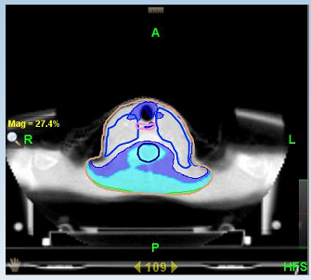

**Figure A2.**  Impact of shoulders on HN dose distribution.  The color wash represents the dose difference due to anatomical changes from the original treatment plan (Cyan: under dose of 0 – 4.8 cGy / Fx, Dark blue:  4.8 – 8 cGy / Fx under dose, no colour wash > 8 cGy under dose).  In this plan, the patient has a 7% lower dose than the planned 160 cGy/Fx (RS)